EDUC 400 Numeracy Toolkit 2021
Please add 5 Numeracy ideas with Grade level(s) to the correct section of this alphabetized Google Doc. Along with a very brief description, you can include links to videos or lesson plans, copies of assignments, etc. Put your name in brackets behind the title.

ADDITION
Addition Around The Room! (Grades 2-3) {Madison Hamborg}
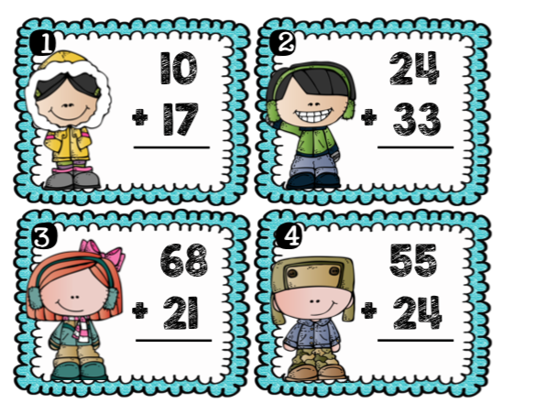
I used these cards, and put them around the room. I had two different levels that were color coded for students to find their cards at their level easily. I allowed students to self advocate for which one they wanted to do (If they chose the easier one and were done quickly I “challenged” them to do the more difficult one) This was a fun activity for them to walk around the room and not sit in their seats for math!
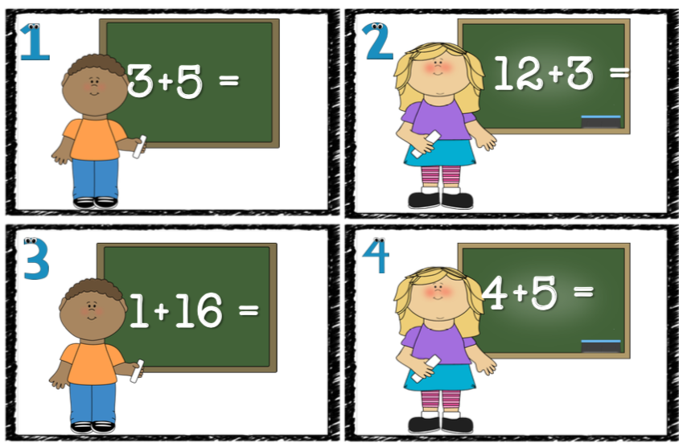

Bump- Math game for addition practice- Grade 1-2 (Sidney Rud)

-This math game is pretty simple, and allows for addition to twenty practice for students. This game would be good to use during an addition lesson to teach the students how to play and then once they know how to play confidently you can continue to use this game for fast finishers and to keep their addition practice up. Students will need a game board template (bonus if you put it in a transparent sleeve so that you can use them multiple times), two 12 sided dice and some manipulative square tiles to use for game pieces.
Rules: 2-3 students per game
-students take turns and roll both of the dice, they then have to add the two numbers they rolled and if it is on their game board they can put one of their tiles on that number
-students go back and forth taking turns doing this, if a player adds to a number that another player that has their tile on, they can “bump” that players tile off
-if a student gets the same number through addition twice they then can place a second tile on that number which creates a stack that cannot be moved
-the goal of the game is to have the most tiles on the game board to win

There are lots of free bump templates online and you can modify this to be for multiplication and subtraction as well. Here is an example of a game board (This was a free download from Teachers Pay Teachers)

Climb the Ladder to 100 Dice Game (Grade 1-3) (Samantha Morey)
For this game the students would ideally work in pairs, but it can also be done individually if needed. The students would each have a pencil and a piece of paper as well as one dice to share between them. To start, they would each roll the dice and whoever has the higher number would go first, then:
- Student 1 would roll the dice to get their first number, they would write this paper down on the paper
- Student #2 would roll the dice and write their number down as well on a separate piece of paper
- Student #1 would roll again and write down their second number, and then add their 2 numbers together to get a sum.
- Student #2 would do the same as above.
- This pattern would continue until the sums get close to 100, then the goal is to get the exact roll so that their sum equals EXACTLY 100. If they roll too high then they have to give the dice back to their partner and try again when it is their turn.
- First student to reach exactly 100 wins the round
This game could also be played at a more advanced level where the students use two dice instead of one, or perhaps have to multiply instead.
Source: My Coaching Teacher from EDUC 490

“I Sea 10!” game (Grade 1-2) (Samantha Morey)
This game is easy and quick to set up, learn, and play so it would be great for filling time or a fun way to get students to practice their addition up to 10 in pairs or individually. Students play the game by taking turns taking the “coins” out of the box, each coin containing a number, and as combined numbers can be added together to make 10 the first student to find the combination of numbers that would equal 10 says “I see 10!”. Then, they would collect the “coins” that equal 10 when added together and show their partner their adding skills. This continues until there are no more “coins” left in the box and the student with the most stacks of 10 wins. There is a shark coin in the box that, if drawn, results in the student who drew the shark to return all of their coins back into the box which ultimately makes the game last longer and adds some excitement.
Source: Bonnie Fuller
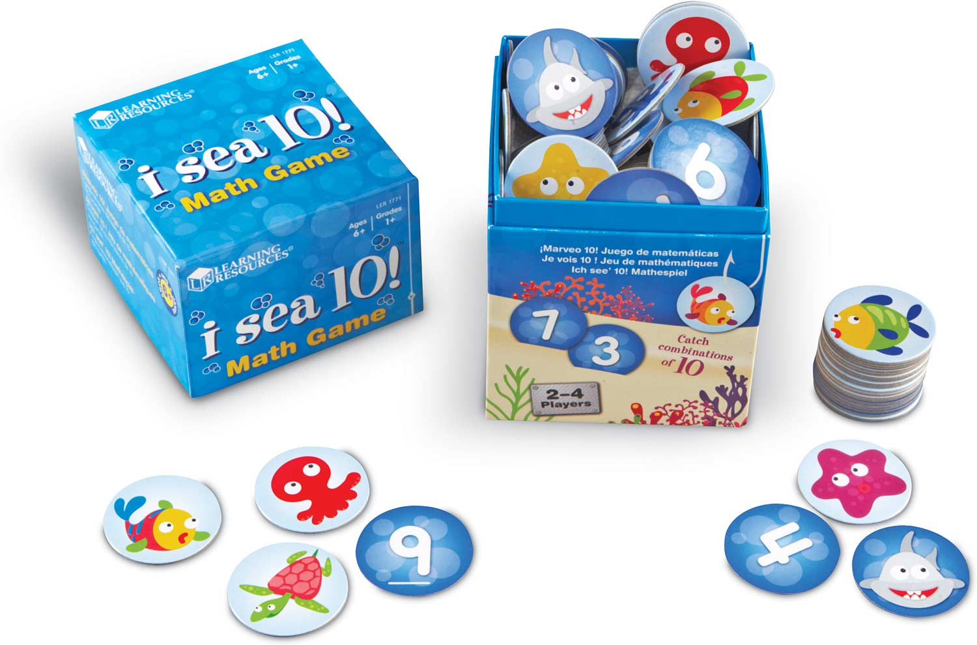

COUNTING

Counting- There was An Old Lady Who Swallowed A Trout - Hannah Trombley (1)
During read alouds whenever possible, I would always include counting where applicable. Counting worked exceptionally well for engagement with this story. Each page had different marine/freshwater animals that increased in number and size. I asked students to show me with their fingers not with their mouth ‘how many’ they saw of each different animal per page. It kept the students engaged and entertained.
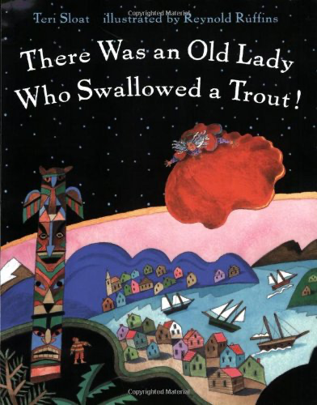

ALGEBRA

Algebra tiles for Solving Equations - Grade 5-7 - Alex Moore

Hand to mind have some great resources. I used these with students when teaching high school mathematics but it could be used for intermediate grades for sure. Students remove tiles or add them to help make it more visual and physical than very abstract.
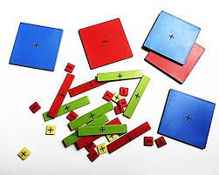
YOUTUBE VIDEO

DATA DISPLAY: GRAPHING
Human Graphing! - K-3 (Sidney Rud)
Human graphing is a fun way for students to explore graphing in a fun and hands-on way. This type of graphing is best done with bar graphing as students can line up in columns to represent our “bars”. You can use a multitude of different topics for this such as birthdays, favourite kinds of pizza, favourite sport, favourite colour, number of siblings etc. You can do this by using tape on the floor to create the base for your graph with your students if you want. There is a picture below of an example of how this can be done (this is not my picture this is from google images)
Source: Lana Rudolph (CT from educ 490)
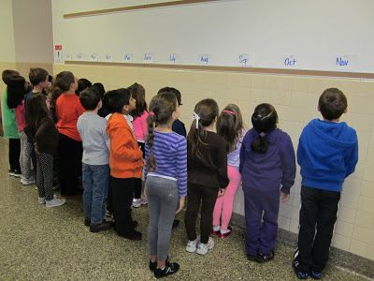

Multi-Curricular Enactment-Sidney Rud
Outline of a Math Core Lesson:
Lesson: Concrete graphs, using one-to-one correspondence (Grade 1-2)
Learning Intention: I can create a bar graph.
Introduction: I show students examples of bar graphs and discus with the class what these graphs are used for and why they are helpful.
Instruction: We co create one based on different favourite types of pizza of the students on chart paper. This is done to discuss different parts of the graph and why we build them. Transition into instructions for individual practice and use the document camera to show students what kind of graph they are creating and what we are graphing. (Have bags/bins full of different coloured tiles for students to use, as well as graphing templates) Show students that we need to separate our tiles by colour and then fill in our graph. Respond to any questions students have about what we need to do.
Independent Student Work: Students complete their collecting of data by separating their tiles into colour groups and using that to fill in their graph. Students can fill out a smiley face self assessment at the bottom of their graph to show how they feel about their graphing skills so far.
Closing: Once students have finished or are mostly finished ask students to turn to a partner and tell them one new thing you learned and one question you have.

Multi-Curricular Enactment #1
Curriculum Areas: Math Graphing and Science: Outdoor graphing with living and non-living things
• For this activity students will be working with partners to build bar graphs with partners
• Our topic for our graph will be exploring living and non-living things
• Review with students what living and non-living things are
• Can have a quick discussion about what sort of living things we may have outside and what kinds of non-living things we may find outside
• Students will first collect their data by going outside
• Once we get outside to our search area partners will be announced and materials will be handed out (hula hoops, pencils, tally sheets and clip boards)
• Students can use hula hoops to make boundaries for their searching area with their partner
• Using a grid template, the students can make tallies for every living and non-living thing they find- This can be further split up into different categories (rocks, sticks, plants, animals)
• Once students are finished collecting their data, we will head back inside to create our graphs from our data
• Using graphing template, the students then can watch the teacher do a sample on the document camera to make sure we know what to do. Students then will take their data categories and use that to build their graph
• Once students have completed their graphs, do a sharing circle with everyone where the students can share their graphs and tell the class on interesting thing about their graph

Multi-Curricular Enactment #2
Curriculum Areas: ELA; Battle of the Books
As part of the Battle of the book’s students will listen to a variety of different books (3-4) and discuss what makes a good story for them.
• Collaboratively decide what different things a good story needs (can do this as a large group or smaller groups) and document on chart paper
• Read through 3-4 story books (this can be over a few lessons/days)
• Once all the stories are read get students to do a silent vote (eyes closed/hands up) for what book they think is the best
• Document the results as tallies for the students to see
• Tell students that now we need graph our results
• Using graphing templates, the students will use the data of our results to create a graph
• When students are finishing up ask them to do 2 stars and a wish for our activity on the back of their graphs

Determining the Strength of Different Shapes (Alex Horner)

Age group: This lesson is aimed at students within an intermediate age group (4,5,6,7).

Lesson intent:
Students have had the chance to cover several units regarding shapes in their education (no matter what intermediate grade). As this is the case, students will begin a project that will teach them about the strength of different shapes relative to one another. This will come in really handy for students as through this inquiry, they will gain the skills to effectively judge shape strengths based on hands on learning and experience.
Format of the lesson:
In this lesson, students will learn about different shapes, specifically what shapes are strongest. The lesson will begin with the teacher asking students about the different shapes that they know. These will be drawn up on the board. Once this is done, the teacher will ask students to predict what shapes are strong/ weak. When they make their prediction, they will explain their thinking and give reasons why they believe that their chosen shape is or is not strong.
Once this is done, I will show a video in class that discusses the strengths of different shapes. (in doing this I am trying to get students to understand the strength of shapes in preparation for our project that we will be starting). After the video, I will pull up several pictures on the board and ask students to find the strong shapes in pictures. What are they and why are they there?
To finish off the lesson, students will write a short reflection regarding the strongest shapes. They will reflect on what makes shapes strong and why this is important for construction. Sheets will be handed in to me at the end of the block so that I can check for understanding.
Multi curricular enactment 1 (ADST):
In this activity (as a follow-up to our first activity), I would like to have students create shapes out of tooth picks and marshmallows. In doing this, students would get to test for themselves what shapes were stronger than others. As the marshmallows will ultimately be the weakest link in the shapes created, students should theorise how structural integrity could be improved. Are some shapes easier to make stronger than others? An activity like this is great as it allows students to have a hands-on connection with their learning. From something like this, students will get to make discoveries for themselves and get to learn in a way that is exciting fun.
An extension of this activity could be a transition towards the creation of popsicle stick/ spaghetti bridges. Using this activity, students would have the chance to build on the knowledge that they have learned in prior lessons and apply it in a fun and exciting way. Although there can be some challenges with glue guns, I am sure we could find a work around that would make all parties happy.
I would have a class discussion at the end of this exercise as to what shapes were best and what challenges students had building their shapes. What were the failure points of your shapes and how could you improve the structure of your shapes? What shapes would you use to do this?
Multi curricular enactment 2 (Science):
Once students have an understanding of shapes and the different strength characteristics of shapes, I would like them to engage in a project where they see these shapes in action in a real-world context. In this project I would like students to create a PowerPoint presentation where in they find a geometric shape (like a triangle or a square) at work within their daily lives. Once students find this shape, I would like them to take a picture of it and describe with several slides, 1. What object the shape is in. 2. Why this shape was used in their chosen object.
These presentations do not need to be long. My hope would be that all students could present within a single class period. The point of this exercise is to get students thinking about the mechanical workings of the world around them. As many students likely have never thought about shapes in their everyday world, this project could act as a catalyst to spark interest and imagination.

DATA: MEASURES OF CENTRAL TENDENCIES

Paper Airplane Contest - Grades 6-7 - Alex Moore

Students are given the opportunity to design three different planes each.
They then have the opportunity to throw them and we will measure how far they go - I always do it to the nearest 10cm to incorporate rounding too. You then can ask them to work out the range and mean of their flights.
We then plot their distances on a graph (use mean if you have a lot of students, or all of the flights if you want) to look at the shape of the diagram. Often it resembles a bell curve - this is ideal. Sometimes it does not!!!
You can then discuss the mode from the graph. I have done median is 3 different ways depending on the students. Either students find their own median from the 3, or they get the median of the flights when they share results with 2 peers (still 9 flights so median is easier to calculate), or if brave I have done it as a class.
There are lots of YouTube videos on how to adapt planes and different websites for designing planes too. I usually combine this with an ADST project too.

DIVISION
Divide and Ride by Stuart J. Murphy -- Gr. 3-4 (Vicki Chen)
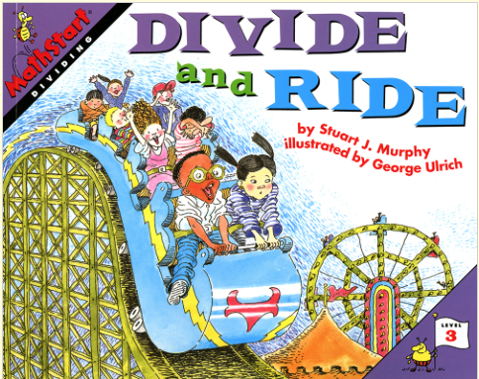
Division is shown to be practical and fun as students are taken through the book’s pages to an amusement park. Before getting on a ride, the children have to add and divide to figure out how many students can fit in each seat or on each bench on the particular ride. In addition to the colourful illustrations, there are number equations as well as charts showing how the division equation can be solved. Students can work on the division equations as they listen to the book being read.

FRACTIONS
Fraction Bar Template- Gr. 4-7 (Nicole M)
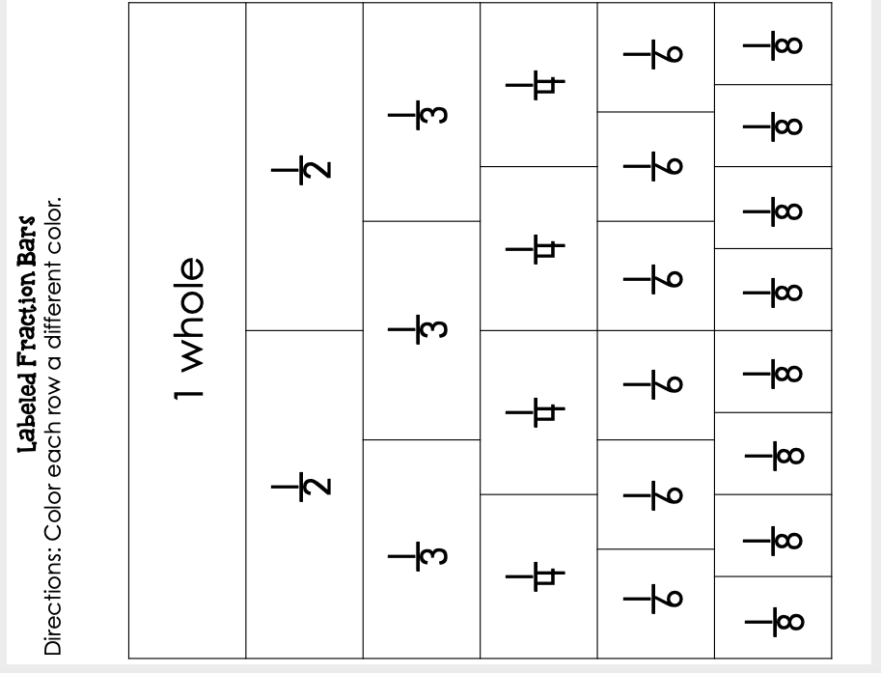
- Get the students to colour each of the fraction bars, and then cut out. Get them to practice forming fractions and make comparisons (equivalent fractions). For more advanced students, give them the fraction bar worksheet without the fractions and get them to figure it out themselves. (If anyone wants this template I have it but it is also free on TPT or screenshot above)
Cuisenaire Rod Set- Gr. 3-7+ (Nicole M)
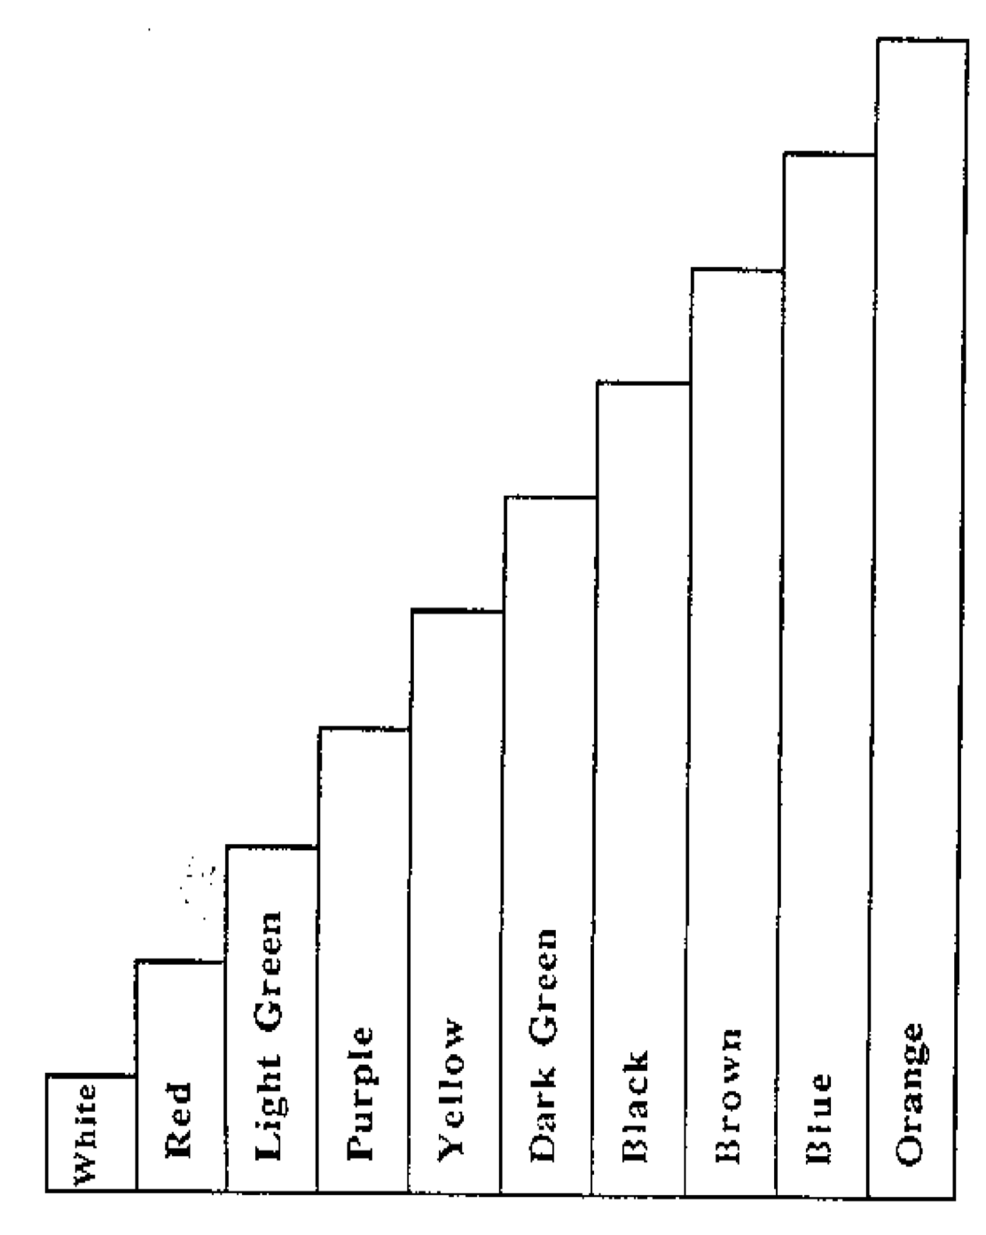
- Paper (template) or plastic (from DLC or schools if they have them), use them to represent fractions. Learning what the colours represent, how to form fractions (¼, 6/8, etc) as well as how to create equilateral fractions and how to break fractions into parts over a whole number. I would highly suggest finding the plastic set, but if printing this off use cardstock paper and keep them in an envelope per student. They are great if your school does not have this resource.
NICOLE
Outline of a Math Core Lesson:
Lesson: Representing fractions and linking it to basic benchmarks (Gr. 4/5)
Learning Intention: Ordering fractions (gr. 4) and whole-number fractions and decimal benchmarks (gr.5)
Introduction: Review a fraction (numerator, denominator). What the top number represents (part of a whole), and the bottom number (the whole). How to represent it in written form and in picture or material form.
Instruction: Using students whiteboards (or plastic slips) put an example up on the board and get students to work through how to represent and form a fraction. Provide 4-5 questions up on the board and circulate to see how students are grasping representing and forming fractions.
Independent Student Work: After handing out simple worksheet, students will answer 5-6 questions on representing fractions in number and picture form. Students fill out response (written or oral specific per learner
Closing: Put exit question aka extension question on the board. When students finish, they can work on exit question. Discuss with partner, provide answer to teacher.

Multi-curricular Enactment #1
Curriculum Areas: Math Fractions/Social Studies
As part of creating fractions and representing them, students will:
- Create a family tree going back to a minimum their grandparents’ lineage
- Summarize their research on their family history ancestry
- Calculate different fractions that represent their family
o 3/10 people are my siblings, 2/10 are my parents, 4/10 are my aunts and uncles, etc.
- View and read 2 other people’s family trees
o Make observations on peer’s fractions of families- more or less siblings, total number of family members, etc.
- Complete co-created (teacher/studented) Self-assessment based on learning intentions combined with
o 3 stars and a wish feedback form

Multi-curricular Enactment #2:
Curriculum Areas: ADST/ELA/Fine Arts/ Math Fractions
As Part of an Inquiry lesson on “Fraction Games”, students will:
- Play a fraction game with a partner in the class (previous lesson)
- Collaboratively decide and create their own game using fractions
o Roll a fraction battle, “bump” fractions, etc.
- Design (draw, craft, digitally create) and test their game
- Write out instructions: introduction, necessary skills, rules and bits on information to play the game
- Swap and test another groups fraction game
- Write 2 stars and a wish for their game
- Fill out a core-competencies self-assessment

DECIMALS

Ordering/addition/subtraction - Grade 6 - Alex Moore

Use base 10 blocks to introduce decimal place value. You can use the 10 x 10 x 10 cube for tens or ones depending on whether you want to go to hundredths or thousandths,
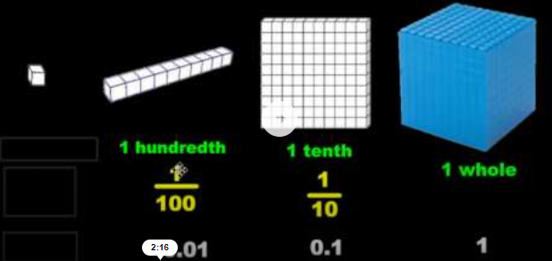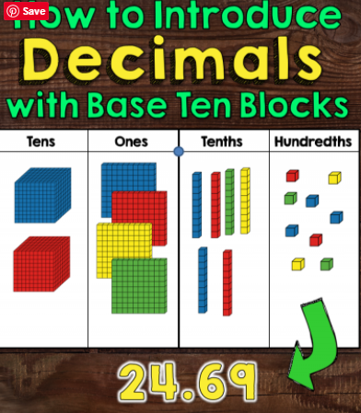

Students can make numbers to compare or order different decimals.
They can then extend this to adding and subtracting decimals.
It helps if students are familiar with base 10 blocks.

Adding and Subtracting Decimals: Grade 4 (Priya Sandhu)
https://www.youtube.com/watch?v=n-OcbG1FlBQ&t=73s
This video is a fun quick song that also explains and shows how to add and subtract decimals. It would be a great video to use when introducing addition and subtraction of decimals. The song is a rap and it is a fun song to sing along with.

First to 1 - 6 (Allison Geyer)
Using a number line (in tenths), two counters/markers, students will roll a die and whatever they roll, they would say it as if they rolled it in the tenths place (IE if you roll a two you would say you rolled two-tenths). Then they would move up based on their roll. If they near 1 but their roll is over, they have to go backwards. So if they are at the 7 tenths place and roll a five, they must go up three-tenths and then back two-tenths. The game ends when someone lands on 1 exactly.

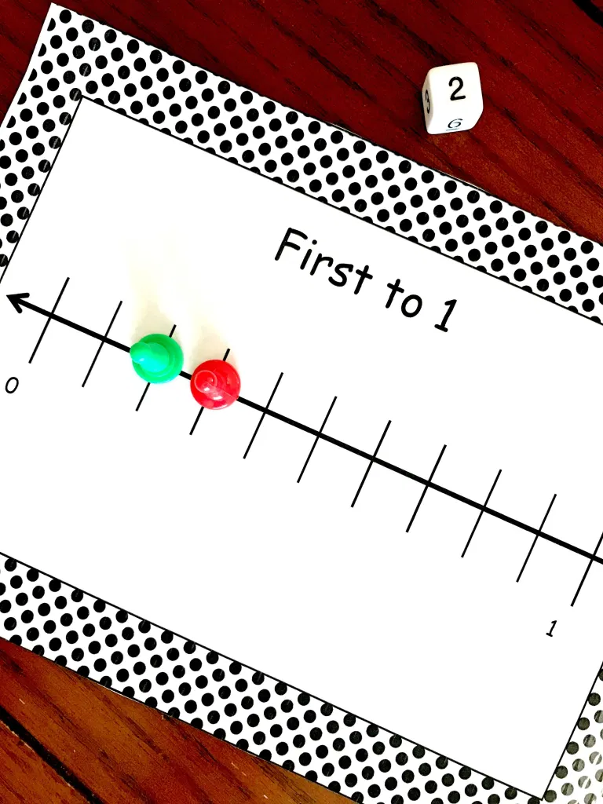
Source

FINANCIAL LITERACY
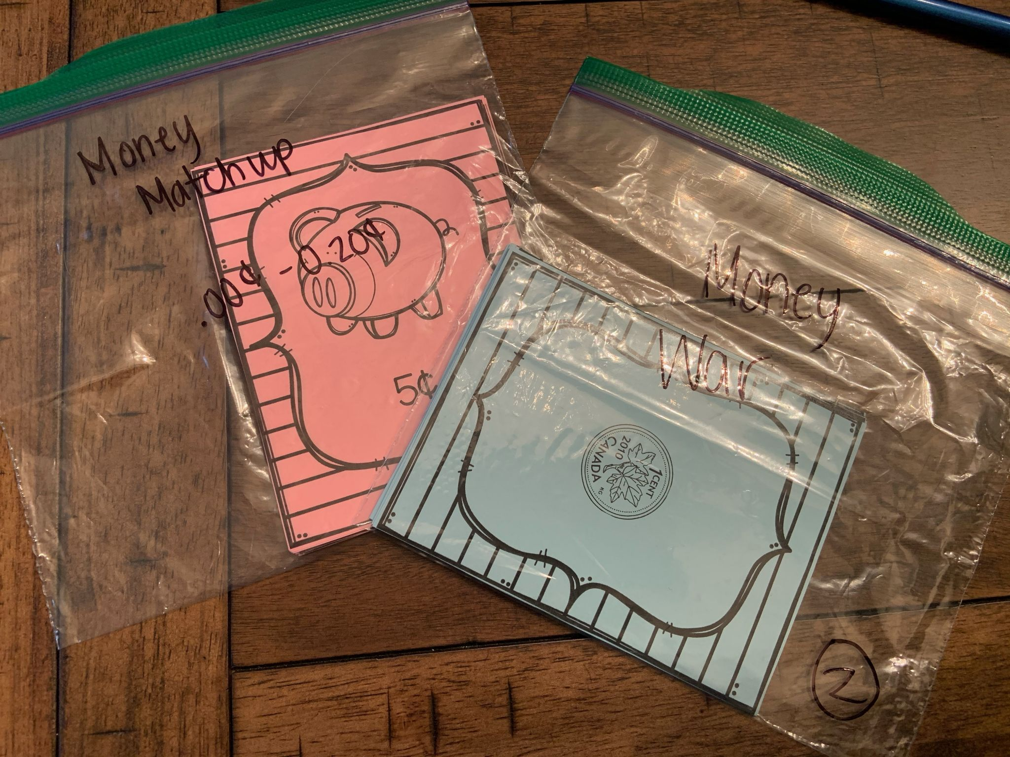
0 cents- 20 cents Finacial Literacy Games (Grades K/1) {Madison Hamborg}
I made 2 versions of the matching game (0-12 cents & 0-20 cents) I color coded the games so the students were able to decide which ones to use. Students could do a simple match the coin to the amount or they could do a traditional version of memory with the cards. I then made a money war game where they play it as if they were playing war with playing cards.

Financial Literacy Grade 1/2 (Hannah Trombley) (2)
‘‘I Have, Who Has’ financial literacy warm up game. For this activity students each received a coin card cutout and needed to listen for cues when their card needed to be read. Students could practice using financial literacy terminology and recognizing the coin face values. Students really enjoyed standing up when it was their turn to read their card. I did fill in the “I have” money value (i.e. “I have 60 cents”) to help students who were having difficulty counting the coins. Source: TPT
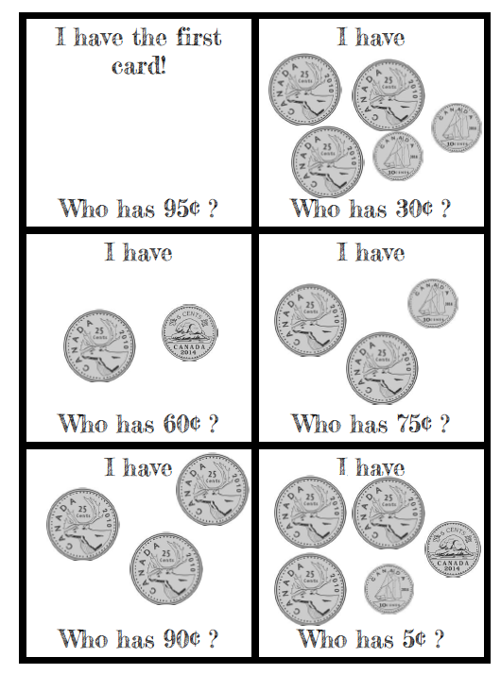
Financial Literacy Grade 1/2 (Hannah Trombley) (3)
An activity the kids really enjoyed as an introduction to our Financial literacy unit were some youtube canadian coin songs- the links are attached below. The coin songs helped familiarize students with coin appearance, value and name. It got the students engaged in the lesson and helped jog their memories before instruction started. I would have students use their hands and laminated coins to help count or participate during youtube videos.
https://www.youtube.com/watch?v=OmBUy3vhTdg&t=54s (Jack Hartman)
https://www.youtube.com/watch?v=qRI1C7oJmhI&t=35s (Coin rap song)

Financial Literacy Grade 1/2 (Hannah Trombley) (4)
Another hands-on introductory lesson I had the students complete during our financial literacy unit was the ‘Itsy Bitsy Coin Book’. This coin book was to support students during independent work to remember and recognize different coin values, appearances and names. The students also enjoyed all the folding that went into making their notebooks as well as colouring them for personalization.
Source: https://www.kidzone.ws/kindergarten/learning-letters/ib-book-cdn-money.htm

Multi Curricular enactments of a Math Concept
Outline for Financial Literacy Lesson #4 from Practicum 490 (Hannah Trombley)
Lesson: Introducing addition of Canadian coins together up to $1.00 (Grades 1 and 2)
Learning Intention: I can begin adding different coins together to come up with a new value
Introduction: Teacher will use attention grabber to capture student’s attention. Teacher will ask students to tidy up their desk space and show active listening. Teacher will let students know we will be doing some coin practice with Canadian coins for math. Teacher will ask students if they would like to watch a Canadian coin song to recap (Rap coin song Jack Hartman coin song). Teacher will let students know we will be playing a quick coin game to practice. Teacher will explain the “I have, who has” game. Teacher will hand out the “I have, who has” cards to students and help facilitate the game.
Instruction: Number Talk Teacher will call students to small white board and ask them to bring their chairs. Teacher will give quick number talk and go over the coins and value (without using decimals). Teacher will go over how students should think of one dollar as 100 cents when adding coins together Teacher will ask: “How can we make 15 cents?” call upon students who wish to answer and use different ways. “How can we make 35 cents?” call upon students who wish to answer and use different ways. “How can we make 65 cents?” call upon students who wish to answer and use different ways. Teacher will ask students to return to their desks once number talk is finished.
Independent Student Work: Teacher will put todays work sheet under the document camera. Teacher will solve problem one with students. Teacher will write correct answer on space provided (23 cents). Teacher will draw popsicle sticks for partners. Teacher will provide coin manipulatives to help. Teacher will remind students they can get out their itsy-bitsy coin book for help. Teacher will allow students to solve problems with a partner. Early finishers can practice with coin addition flash cards.
Closing: Teacher will have a quick review question ready on white board to wrap up lesson (using laminated coins). Teacher will ask students to write their answer on a slip of paper with their name (exit slip). Teacher will have students tidy up for lunch and wash their hands.
Multi Curricular Enactment #1
Curriculum areas: Financial literacy and ELA
Students will practice their number sense by participating in a classroom auction by biding. Students will be frontloaded about what an auction is, how to place a bid, and how to increase one’s bid to win or secure the item up for auction (supported by YouTube video or class demonstration).
· Students will select random classroom items (some supplied by teacher) such as books, markers, paints, manipulatives, centre items, laptop etc.
· Students will each get a number card to raise when placing a bid
· Students will receive list of items and blank space to provide what each item sold for
· Students will need to use their financial literacy terminology when participating in classroom auction
· Students will place ‘bids’ on classroom items up for auction (teacher is auctioneer)
· Students who have made any purchases will need to write 1 or 2 sentences in their journal explaining why they purchased the item and placed the bid they did (over paid, under paid)
· Students who did not purchase any items will also need to explain why they did not place any bids in 1 or 2 sentences in their journal
· Teacher will end the auction lesson by having a discussion with students about their choices for an open-ended questioning and reflection period
This ELA approach to financial literacy supports student communication as well as proper terminology practice and use of mathematical language.
Multi Curricular Enactment #2
Curriculum areas: Financial Literacy and Career Education
Students will practice their goal setting strategies and identify the steps required to achieve short term goals by saving up to purchase something they want.
· Students will come up with their own classroom rewards system (Sit by a friend for the day, watch a movie, use teachers chair etc.)
· Students will be front loaded on goal setting information and strategies
· Students will earn classroom money by completing their daily jobs (for example: sweep, stack chairs, take recycling to kitchen, hand out papers, erase white board)
· Students will need to make a savings goal to purchase one of the rewards and write it down and sign it with the teacher
· Students will need to save up their earned classroom money to purchase their set goal item
· Students will be able to put their money together to afford more expensive rewards like a pizza party
· Students will learn how to save money to put it towards something they want
Practicing goal setting with the inclusion of financial literacy are important skills to learn when students become more independent with their own money and earnings later on in life.
Multicurricular Enactment Decimal Diner grade 4 (Priya Sandhu)
Learning intention: Students will understand how to use problem solving skills to make monetary calculations that include decimal notations in real-life situations.
Lesson plan: Students will get a concession menu with prices and a sheet for them to write their answers. Students will get a set of addition and subtraction questions using money to go along with their menu and they must answer those questions.
I will begin the lesson by explaining that when you are dealing with money calculations, it is important to understand decimals. I will give the class some examples of how to add and subtract money. I will give the class a concession menu with prices and a sheet for them to write their answers. I will put a question on the projector and have the class try and solve the question on their own. After a few minutes I will ask for a volunteer to show how they got the answer on the board. I will continue doing this for about 12 questions. Students will try to solve the question on their own. They will then either contribute their answer to the class or follow along while another student explains their answer on the board. I will then instruct the class to create their own word problem/problems using the menu items and prices I provided for them. I will circulate while they are coming up with their own problems and assist anyone who has questions. I will collect the word problems that the students created and ask the class to reflect again on why understanding decimals is important when dealing with money. Students will hand in their word problems and contribute to the class their understanding of the importance of decimals and monetary calculations.
Multi-Curricular Enactment 1: Financial Literacy/ Fine Arts
- Students will get into groups and create their own restaurant menus on a poster board
o The poster board will include drawn and colored pictures of food items they would like to include
- They will create prices, with decimals, for each menu items and a worksheet to go along with their menus
o the worksheets will include questions that the students have come up with themselves.
o The worksheet questions will be addition and subtraction questions. For example, they could ask a question like: If Josh ordered 1 burger, 1 medium fries, 1 coke, and an ice cream for dessert, how much would Josh’s bill be?
- After the students have created their menus, they can visit three other restaurants (Or everyone’s restaurants) and fill out the worksheets for those restaurants.
- Students will be collaborating together to create this restaurant menu and the worksheets that go along with their restaurant.
- Students will be using their artistic skills to design their restaurant and use their understanding of decimals and financial literacy to create and answer worksheet questions.
- An extension to this assignment could be making the menu items healthy and explaining why they are healthy and good foods to eat.

Multi-Curricular Enactment 2: Financial Literacy/ ELA
- Students can create a story that involves adding and subtracting money.
- I would get the students to create a word problem that includes adding and/or subtracting with money, they need to also solve this problem.
o After the student creates their word problem, they can create a short story around this problem.
o For example, they could write some along these lines: It was a hot summer day. I could hear the ice cream truck coming down my street. I excitedly ran out to the ice cream truck. When I got there, I realized I had 2 loonies and 3 toonies and 3 quarters. All together I had $8.75. The cotton candy ice cream I want to get is $3.75, so I can definitely get one. Can I get another one? I quickly did the math and realized that 8.75-3.75 leaves me with $4.00. So, I can get two ice creams and have 25 cents left! What a great day.
o I would show this example to the class and tell them to come up with their own math problem story
Crab Pots - Grades 5-7 - Adaptable for other grades - Alex Moore

Crab pots is a great way to teach a variety of different ideas. It covers all four operations and you can adapt the numbers to what you as the teacher want.
Students buy pots with hypothetical money (could use manipulative money and a bank but mine don’t like it as it slows the game down).
They then make choices about whether they risk their pots to make more money.
Adaptations / real world considerations:
- If the weather is bad, the pots at sea get destroyed.
- You make more from pots at sea as they catch bigger crabs.
- Students have a limit on how many pots they can use in a day - as humans are limited by time, resources, etc.
- Lottery is a good addition when discussing probability experiments etc.
I used this for my lesson plan for Heather and I have attached the resource and the lesson plan. It always works best to start in small groups to explain it.
SPREADSHEET LESSON PLAN

GEOMETRY: 2D & 3D

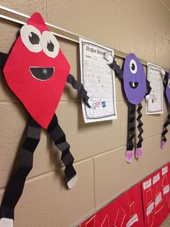
-2D Shape Monsters: Analyzing and exploring 2D shapes- Grade 1-2 (Sidney Rud)For this activity the students created a shape monster by having the body of their monster be one of the established 2D shapes. For this activity I also got the students to do a written component to identify what kind of shape their monster was, how many sides and corners it had and they gave their monster a name for fun.
Source: http://mrswheelerfirst.blogspot.com/2014/04/geometry.html

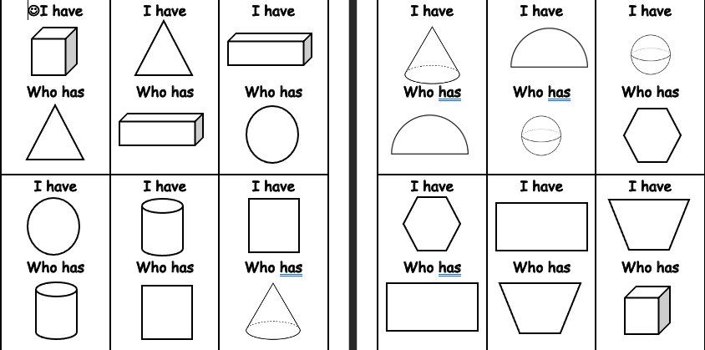
2D & 3D I have.. Who has… (Grades 1-3) {Madison Hamborg}
I created two sets of this to make a class set, and I colored them different colors for them to work on their colors as well. When I was passing these out-- I gave the 2D shapes to students who I knew were not yet strong with 3D shapes. This is very good practice for all learners in the class, and they will work together to find who has the matching card.

3D Shape Song- Grade 1-2 (Sidney Rud)

- This song is a super fun intro to what types of 3D shapes and the creators do a great job of comparing them to real life objects. You could use this for an introduction to 3D shapes to establish different kinds of 3D shapes or a review of types of 3D shapes. This song comes from Math songs by NUMBERROCK on youtube.

https://www.youtube.com/watch?v=ZnZYK83utu0

Outline of a Math Core Lesson (Vicki Chen)

Lesson: 2D shapes, 2D shape names, and the attributes of 2D shapes (Grade 2)

Learning Intention: I can identify 2D shapes and their attributes.

Introduction: To engage the students, I play “What Does the Fox Say?” (Youtube https://www.youtube.com/watch?v=CEvxAV8MPyo video 3:45 mins.). I draw 2D shapes on the white board and ask the students to out up their hands if they know the names of any of the shapes. I ask, What do you notice about these shapes? How many sides do they have? How many corners?

Instruction: I play the game “What Does the Shape Say?” (Using the same beat as What Does the Fox Say?” The Game is played on chart paper. I give each student either a Name of the Shape or Speech Bubble attribute card. I ask the students to read the card. I model the game by asking a student with a Clue Card to come forward. Then we all say, “What Does the Shape Say?” The student then reads the Clue. The class chants, “What is Your Shapes Name?” The student with the matching shape card stands up and calls out the shape’s name. Both students take the shape and the Clue to attach to the Chart Paper.
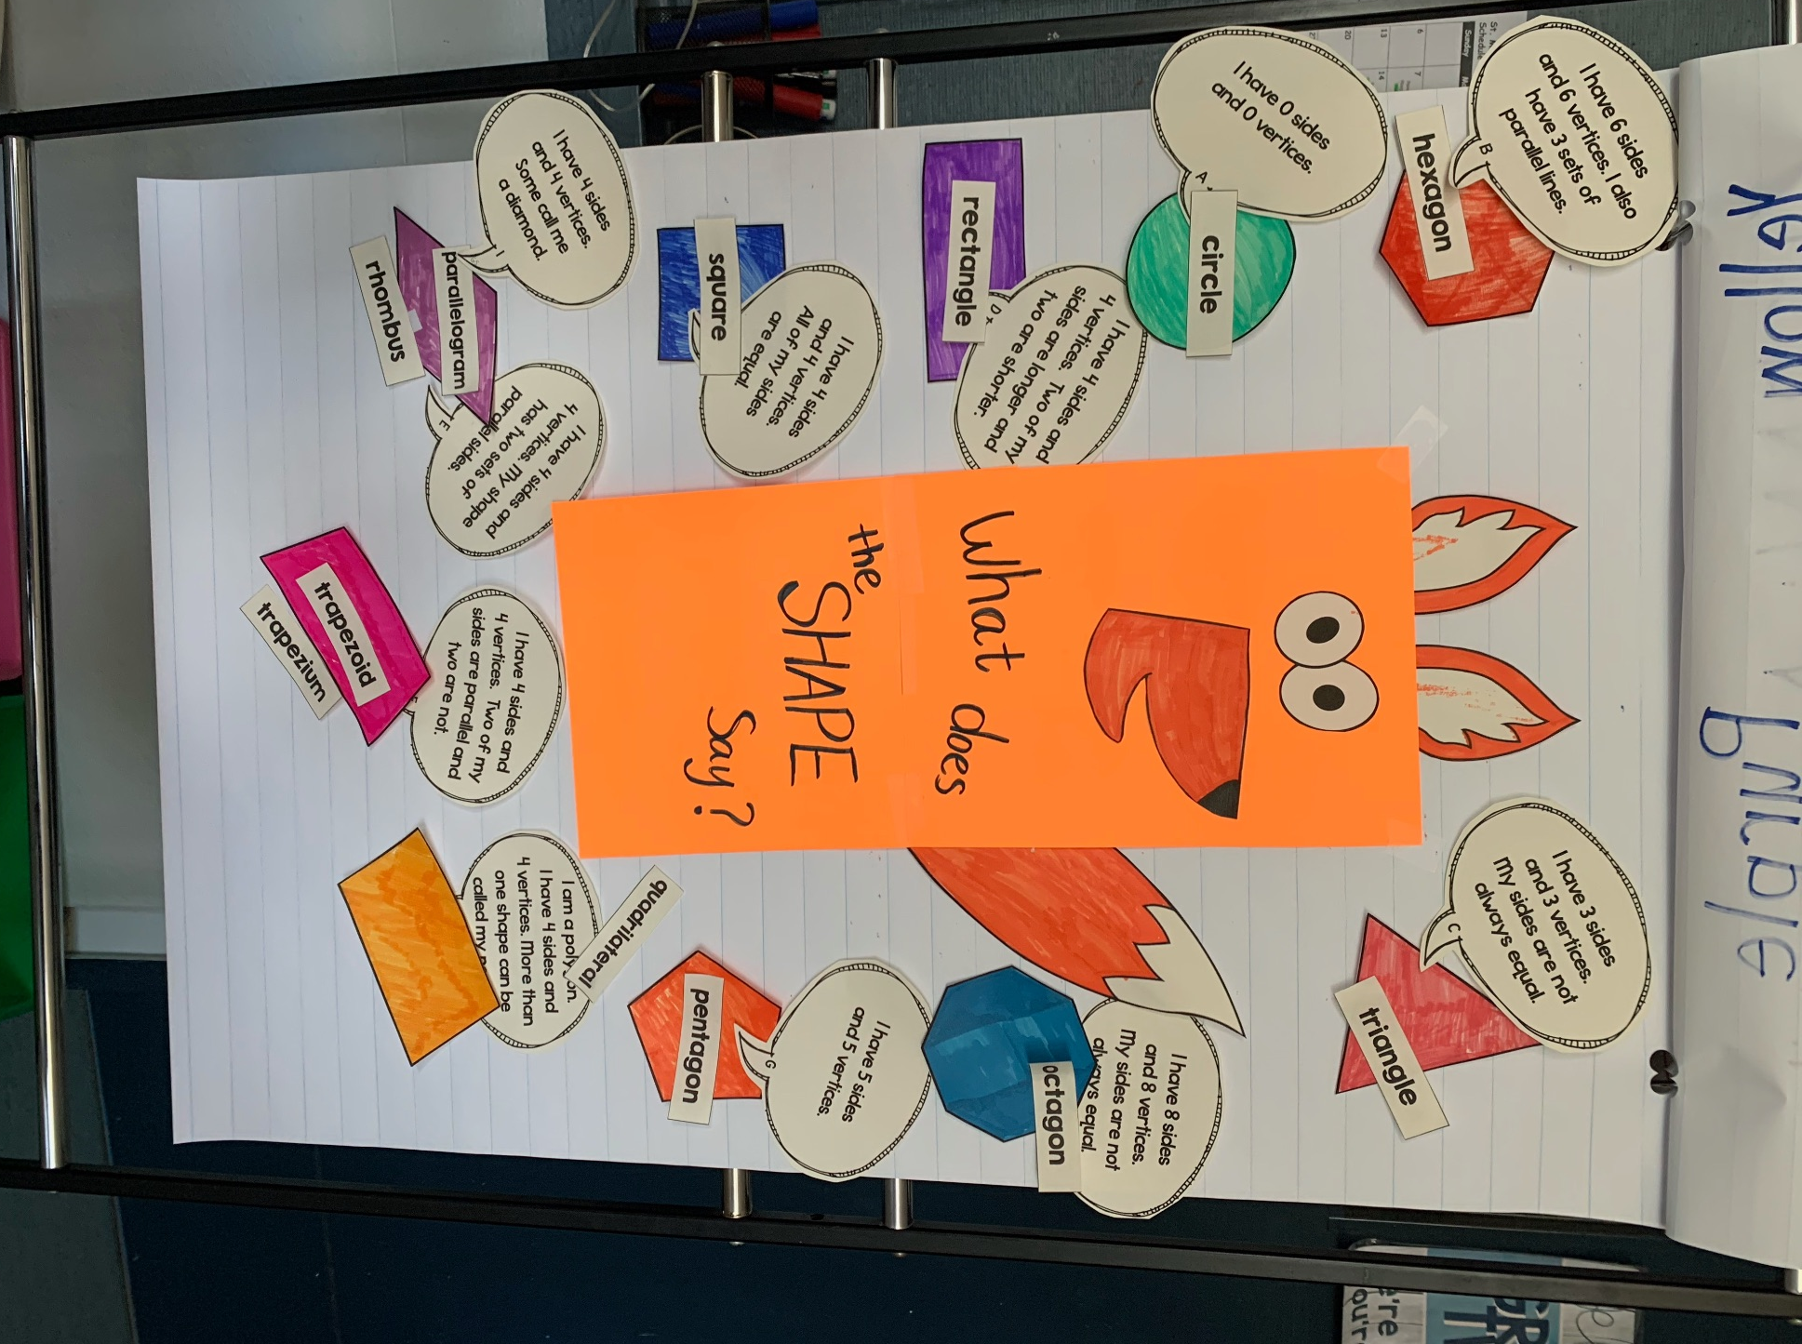

Independent Student Work: Students then take turns, each Clue Card leading the class to chant, “What Does the Shape Say?” and after reading the Clue, the students chant, What is your shape’s name? The student with the matching Shape Name then shouts out the name. Both students attach their cards to the Chart Paper. Once the 2D Shape Chart is complete, students can tidy up.

Closing: In the closing minutes, I would review the shape names and the shape attributes, complementing the students work.

Multi-Curricular Enactment #1

Curricular Areas: 2D Shapes/ Art Education/ ELA

The Self-Portrait lesson’s objective is to experiment and play with the knowledge gathered about 2D shapes. Using 2D shapes, students will compose a self-portrait. For examples, students can use whatever 2D shapes they like to build up a picture of themselves. After finishing the 2D Self-Portrait, students will write a poem about one’s self using the constraint of including at least two 2D Shapes. For example, “My ears are triangles, and my mouth is a square.”

Some students will finish more quickly than others, so I would encourage them to add more detail. Students who struggle can practice using two or three 2D shapes to build confidence.

Students will
Reflect on the names and attributes of 2D shapes
Reflect on the presence of 2D shapes in their environment, even in their own face
Be creative in how the interpret their self-portrait
Be creative in writing a poem about one’s self

Multi-Curricular Enactment #2

Curricular Areas: 2D Shapes/ Social Studies/ ADST/ Addition

The objective of the Community Building exercise to reflect on the attributes of 2D shapes as well as the attributes of rural, suburban, and urban communities.

In groups of 4, students will develop a map of either a rural, suburban, or urban community. Each map will begin with a road network that leads off of each page (and can thus be connected to the other maps). Using 2D shapes, students will draw a map of their assigned community. At the end of the exercise, the maps will be joined to show how different kinds of communities are connected and work together.

Students who finish quickly can make a tally of the number of certain 2D shapes they used in their maps. These students could also be encouraged to add more detail.

Students who need more time can focus on the key attributes of their assigned community.

Students will
Reflect on the attributes of 2D shapes and rural, suburban, and urban communities

Multi-curricular Enactment #1 (Allison Geyer)
Outline of a Math Core Lesson:
Lesson: Identifying 3D objects by their mathematical terms (e.g., sphere, cube, prism, cone, cylinder) (Grade 3-4)
Learning Intention: I can identify 3D shapes using models.
Introduction: I go over the principal 3D shapes; what they are, what their names are, what faces, vertices, and edges are, where we can find examples of them in our everyday environment.
Instruction: I hand out the wooden block shapes and have students make verbal observations of the shapes.
Independent Student Work: Using graph paper, students will redraw the 3D shapes before them and write down 2 – 4 key observations they’ve made based on the shapes. Noting their faces, vertices, and edges where applicable.
Closing: Students will share with their neighbours what they’ve learned, exchanging notes if they haven’t completed their notes.
Curriculum Areas: Math (Construction of 3D Objects)/Science (Biodiversity)
With the intention of having a greater understanding of both 2D and 3D shapes, and the diversity of characters among plants, animals and fungi students will:
· Use wooden blocks of 3D shapes to construct their “creature”. Have one shape be the creatures “special characteristic”.
· Draw the creature in 2D on graphing paper: naming the shapes used to build it.
· On a separate sheet of paper, students will give the creature a name/species (IE. Trilangularsaurous). Students will be given time to create a biography on the creature: Where does it live? What does it eat? Does it live in pairs, groups, or alone? Student’s will write on the shape that was the creatures “special characteristic” and explain why it is important to the creature.
· Divide the class in four groups, two groups will be displaying their creatures at a time (this way everyone should be able to see everyone else’s creature). Students will explain the shapes they used and features about the creature.
· Bring the class together, have students answer prompts that reflect the competency: “what shapes were most frequently used?” “why might some shapes have been easier to use than others?”

GEOMETRY: MOVEMENT AND LOCATION

Back to back drawing - Grades 5-6 - Adaptable for other grades - Alex Moore

Students sit back to back. One is given the description page and one is given either a white board, or plain/square/coordinate grid paper, depending on what you print it on.
One student gives a description of what is in front of them for the other to draw without seeing. You can print them on square grid or coordinate grid paper depending on what you are teaching. You can also adapt the image depending on what grades you teach. The shapes can vary too.
You can also use a similar idea in Gym for a maze you make on the floor and blind fold one student.
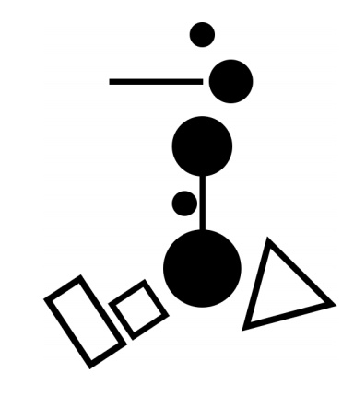

Transformation Art – Adaptable Grades 5-7 (Keely Murray)
On 3 piece of graph paper with an X-Y axis drawn on it, students create an image in the upper left quadrant. This should be the same image on each piece of paper. On one paper, they then recreate the image in the other quadrants using only reflections. On the second paper, they recreate the image in the other quadrants using only rotations. On the third paper, they recreate the image in the other quadrants using only translations. For grade 6 and 7, this activity could be adapted to use combinations of transformations when transforming their image from one quadrant to another.
Source: https://thenumbertwentyone.wordpress.com/2013/02/11/transformations-project/
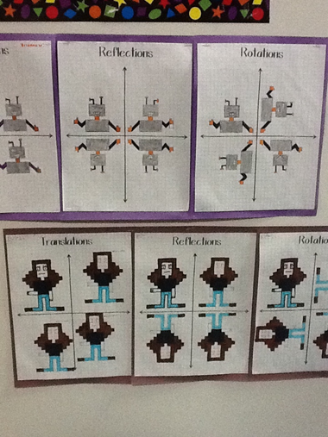

GEOMETRY: ANGLES

(Grade 4,5,6) Some students find geometry boring and confusing. “When will I ever use this?”, they think to themselves… To give students a better sense of the importance of geometry and angles, bring in interesting topics like mapping or stars. This can make the topic a lot more interesting, and also act as a great hook for a lesson. (To introduce the lesson, I brought in a sextant and briefly explained to students how using angles can help to calculate your position on earth) (Alex Horner).

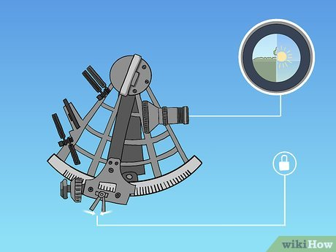

What’s Your Angle, Pathagoras? by J. Ellis -- Grade 6, 7, 8 (Vicki Chen)
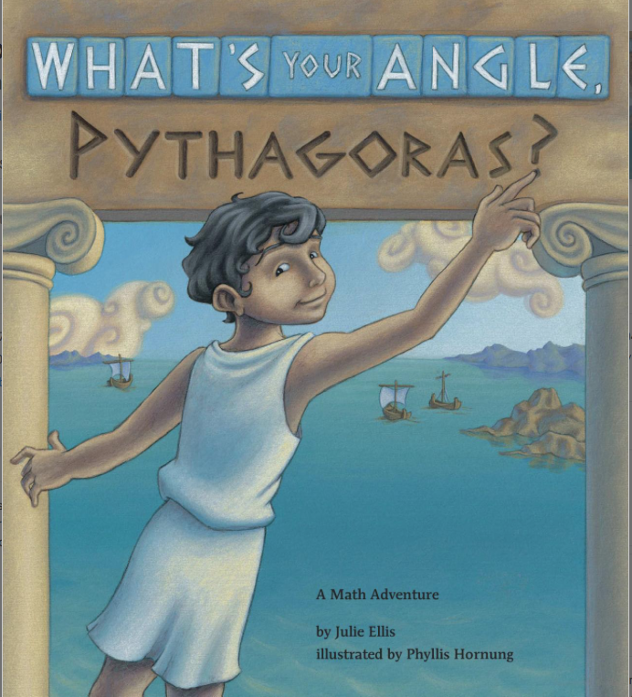
The historical story is simple as a curious boy goes on a business trip with his father; however, the story soon starts conversations about Ancient Greece and Egypt. The mathematical concepts are clearly stated, and there are clear visual examples to build upon the written concepts. The story makes learning about and measuring angles fun as it ignites natural curiosity about the world.

Outline of a Math Core Lesson (Samantha Morey):
Lesson: Angle Measurement and Classification of Polygons (Grade 6)
Learning Intention: I can measure and classify any or all angles of a polygon.
Introduction: I draw different shapes up on the board and we have a discussion about which angles are bigger in which shapes (starting with the basic squares, triangles, circles) so that students can identify what we are looking at when discussing angles. Then, as a group, name those angles (obtuse, acute, reflex, right).
Next, I would give a demonstration on how to use a protractor. Then hand protractors out so all students have one.
Instruction: The students would be given protractors and a worksheet with a variety of angles, first off focusing on identifying the type of angle and then going into measuring the angles.
Before getting the students started, I would use the worksheet to demonstrate a couple more examples of what the students will be doing so that they could follow along if they needed to.
Independent Student Work: Students work on completing the work sheet identifying the angle types and measuring. While they work, I would circulate to help (I found in my class that students were constantly using the protractor backwards, so I would especially be looking for that).
Closing: I would quickly go through the worksheet together as a class, getting each student to either classify the angle or give us the measurement. At this point they should already have it answered on their own sheet so the process should not take too long. However, time should be set aside to go through the question together if the student provides an incorrect answer or most of the class seems confused by the question.

Multi-Curricular Enactment #1
Curriculum Areas: Angle Measurement and Classification / Art / ELA
The goal of this lesson would be to provide the students with a list of types of angles as well as some exact measurements of angles and then to have the students incorporate each of the angles into a drawn art piece. Their drawn art piece will be of a setting or character from either whatever silent reading book they are currently going OR a character or setting but the book that is read during read aloud time. The aim of the activity will be for the students to draw this character or setting while paying special mind to the angles, trying to include and label as many as possible. Students will:
- listen to the instruction and review as a class the different classifications of angles, help to provide examples, and to review how to measure angles.
- look at an example of art together as a class and search for angles, trying to classify them as they are found
- decide what character or setting from which book they would like to draw, taking a look at the description in the book again if needed to refresh their memory on the details.
- visualize and begin to sketch what they might want their picture to look like, keeping the angle requirements in mind
- create their art, labelling the angles as they incorporate them into their art.
- double check that they have as many of the requirements as possible labelled in their finished product
· * some students will be better at art and with their fine motor skills than others, therefore the summative assessment should only be on the angles themselves and not on the quality of the art. some students may just have shapes connected to shapes while others could potentially add depth to their work, either option is adequate! *
Multi-Curricular Enactment #2
Curriculum Areas: Angle Measurement and Classification / ADST / Career Education
The goal of this activity is for the students to create a perfectly cube-shaped wooden crate that is strong enough to carry materials in. The crate would have all sides except for the top, which would be left open. Students will:
- review what a perfect right angle is
- identify perfect right angles in the classroom around them
- look at an example of a crate, each taking their turns looking closely at the inner and outer angles
- make note of how all of the angles are similar (they are all right angles)
- observe and learn how to use a level
- look at and gather materials (15 2”x6” pieces of wood and wood glue)
- glue their pieces together using the wood glue to create their crate
- use levels to check their sides/angles before glue completely dries
- once crates are finished, students will be paired with another class and act as the teachers to help their partner build their own crate
- the expectation is that the students need little to no help from the teachers, and instead can work together with their experience and the materials to help others build their own
- the students will need to make sure in their explanation that they are describing the perfect right angles and placement of the boards so that the crate is functional, and all the pieces fit together
- once all crates are completed, the students can all paint their crates together and decorate them however they would like

MATH ROUTINES (K-7)
Esti-Mystery – Adaptable for Any Grade (Keely Murray)
Two to three mornings a week begin with an Esti-Mystery, chosen from Steve Wybourney’s website. Students are shown a picture of a container that is full of objects (ex. A glass full of dice) and are asked to estimate how many of the object are in the container. The teacher records the estimations, and students record their own estimation on their dry erase hundred charts. Teacher then one by one puts up a clue (ex. “The number of dice is less than 90” or “The number of dice is an odd number”) and students cross out numbers on their hundred charts. By the time all the clues have been given ( about 4 clues) students should have narrowed it down to a few actual numbers that the answer could be, and are asked to make their final estimate on which of these numbers seems like it should be the answer. Teacher asks students to explain why they chose the number they did, and finally reveals the actual answer.
Grade: I used this with grade 5 and observed it in grade 3/4, but there are Esti-Mysteries of different levels of difficulty, from kindergarten to grade 7, so it could be used with any grade. Even with older grades, it would be good to start with easier Mysteries so students can get used to the routine of the activities.
Source: https://stevewyborney.com/2019/09/51-esti-mysteries/

Number Corner- Measurement:Area - Gr. ⅘ (Nicole M)
- Every morning a different 3D shape would appear, students would guess the pattern based on the previous day, and figure out the area. This introduced multiple different pattern strategies (how to recognize them and predict future pattern) and was a simple introduction to volume in terms on either counting squares or using the numbers provided (LxWxH)

Number Talk - Addition and Subtraction - Grade 2 (Vicki Chen)
Every math lesson begins with Number Talk. For example, students are asked to mentally solve an addition equation. When students have an answer, they put their hands up, and when called upon, state their answer. Then, further explanation is requested. “How did you get your answer?” Regrouping, borrowing, adding, etc. An emphasis is placed on polite language especially when there is a disagreement on the answer or the process.
Source:https://www.youcubed.org/resources/stanford-onlines-learn-math-teachers-parents-number-talks

Words of the Day - Geometry (on any math unit that has a lot of new words) (Alex Horner)
- If a unit has a lot of new words that are constantly changing/building on themselves, write down all the words that students will face on that day's assignments on the board. Do this at the start of the day so students have a chance to guess meanings and make connections for themselves before the lesson.
- Go over terms during the lesson.

Number Talks k-5 (Priya Sandhu)
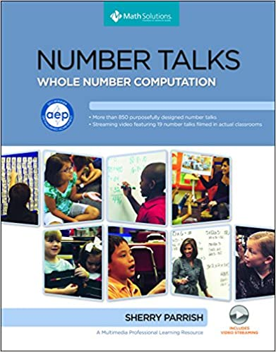This is a great resource that my CT used to design some good number talk activities and help develop student’s strategies when dealing with addition, subtraction, multiplication, and division.

Number Talks Grade 4 (Priya Sandhu)
These world problems are very challenging. This worksheet has the questions and the answers.I did these word problems with my class and we talked through the answers together. This problem really stumped them and they enjoyed trying to figure it out.
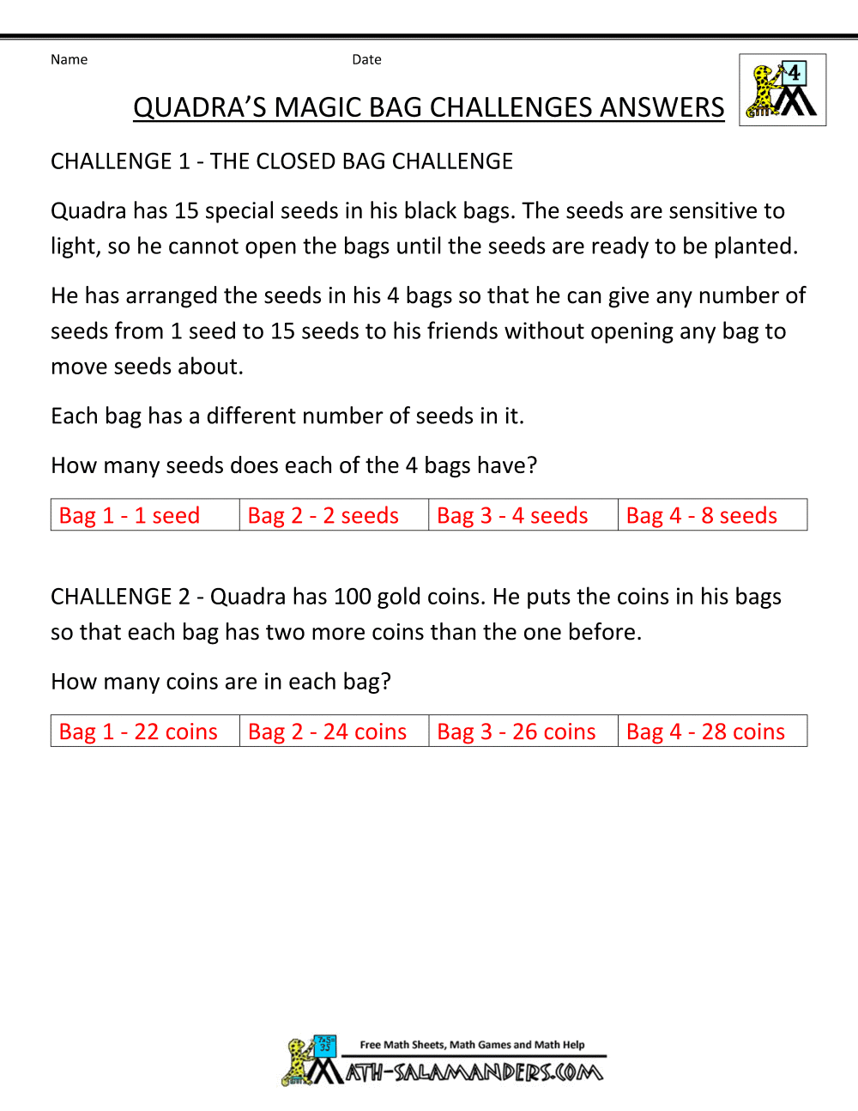

Number Talk - Financial Literacy - Hannah Trombley (5)
Before moving on to independent work for my financial literacy lessons I would always refresh students with a brief number talk (about 10 minutes). I would have all students move and sit in front of the classroom portable white board on wheels. All the laminated coins they had learned were at the top. I would point at each one and ask “What is this called” “What does it look like” “What is it worth”. Students were either called upon or answered together. I would then scaffold and ask students to add a dime and nickel together, or penny and dime together- and call upon students. To make things more difficult I would ask students how I could make 65 cents (for example) and I would accept different ways. Students would show me their understanding by using the names of the coins and proper value. Number talks would prime and front load them to do their independent or partner work.

MEASUREMENT: AREA AND PERIMETER

Area and Perimeter - Assignment 2 with Design a Farm inc. French animals and Design and Build a Gingerbread House with Christmas around the World - Alex Moore
If you want the French resources for animals, colours, numbers, personality traits, let me know. They are on my work computer.

Numeracy Assignment 2 Write Up
Design a Farm Project
Farm Constraints
Farm Value Page
Christmas around the World PPT
Gingerbread House Project - From TPT - I adapted it.

Area and Perimeter Names – Grade 5-7 (Keely Murray)
Students write their names using bubble letters on graph paper, while making all sides of their letters straight lines (i.e. everything should be squares or triangles). Once they have their letters drawn, they measure and record the perimeter and area of each letter (remembering proper units!). Students will also calculate the total area and perimeter of their name. All of this should be written on their piece of graph paper. Optional: Have them colour their names so you can display their math art.
Source: I got this idea from my CT but there is an outline here on Teacher’s Pay Teachers for $1.00 (currently on sale for $0.90). You can easily do it with just graph paper, though. https://www.teacherspayteachers.com/Product/Perimeter-and-Area-Activity-My-Name-3826511
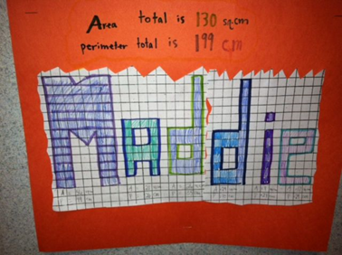

How to Find Area and Perimeter (Rap) – Grades 5-7 (Keely Murray)
This video by Flocabulary features a rapping spaceman trying to create a yard on Mars for his dog, and goes through different ways the spaceman could find the area and perimeter of his yard. This could act as either an introduction to area and perimeter for grade 5, which you would then follow up with more in depth explanations, or could act as a review of the concepts for older grades that have already covered area and perimeter.
Source: https://www.youtube.com/watch?v=rSVMrPu0__U

Outline of a Math Core Lesson (Keely Murray Assignment 2)
Lesson: Measuring perimeter of a shape by adding the length of each side (Grade 5)
Learning Intention: I can add the length of each side of a shape to calculate the perimeter of the shape.
Introduction: Ask students to think about the idea of perimeter while we watch Flocabulary’s How to Find Area and Perimeter (https://www.youtube.com/watch?v=rSVMrPu0__U). Have a brief discussion about what perimeter is (the distance around an enclosed shape), how the perimeter of a rectangle is calculated (all the sides added together), and whether they think this could be expanded to shapes that aren’t rectangles (it can). Tell students that we’ll be talking about area in another lesson.
Instruction: Draw a rectangle on the board. Ask students how you would calculate the perimeter of this rectangle and use a meter stick to their directions to measure the perimeter. Next, explain to students that we will be heading outside to measure and record the perimeter of different things. Remind them how to calculate area. Hand out clipboards, papers, and tape measures to students, and have them head out to the courtyard. Use guided practice on something (for example a 4 Square court) and have students measure the perimeter for the class, and then have a few students point out specific things that they could measure the perimeter of.
Independent Student Work: Students pair up (easier for using tape measures) and are instructed to measure and record the perimeter of 3-5 different things (number can be adapted for students’ understanding and time frame). They should record what it is they are measuring the perimeter of, draw a diagram of the object, labeling the length of each side, and record what the perimeter is.
Closing: Teacher brings students back together, and has each pair share one thing they measured the perimeter of, and what that perimeter was. Brief discussion on what was easy about perimeter and what was difficult.
Multi-Curricular Enactment #1
Curriculum Areas: Math/Art
As part of a perimeter art lesson, students will:
- Draw a person/animal/alien/robot on a piece of graph paper, using only straight lines (following the lines of the graph paper or drawing straight diagonal lines). This character should have at least 7 distinct body parts (hair, shirt, pants, head, arms, antennae, etc.)
- Colour in their picture, making the perimeter of each body part pronounced (outlined in Sharpie or thin marker)
- Measure the length of each side of each body part and record it on their picture using a fine liner
- Calculate the perimeter of each body part. Calculate the perimeter of the entire character
- On a separate piece of paper, students should list the body parts as well as the character’s name, and record the perimeter of each part next to the names of the parts and the perimeter of the whole character next to its name
- If students have learned area of rectangles and triangles already, have students calculate and record the area of each body part and the whole
Multi-Curricular Enactment #2
Curriculum Areas: Math/ADST
As part of a measurement/perimeter/area “Build an Amusement Park” project, students will:
- Discuss what things need to be in their amusement park (fence around the outside, rides, games, food places, bathrooms, etc.)
- In groups or 2-3, create a blueprint of their amusement park, including measurements for lengths of sides, perimeter, and area of everything within it, as well as the overall measurements of the boundary of their amusement park (area, perimeter, and lengths). The blueprint will be smaller than the actual creation, so teacher should make sure students remember this and know that their measurements are more important than making their blueprint exactly to scale. Students can even use masking tape on the floor of the classroom or hallway or in the courtyard to measure out how big they want their overall area to be, and can use measuring tools to see how long they might want to actually make something. Teacher will give a maximum area that their amusement park can be, so students need to keep this in mind as well.
- Build their amusement park using cardboard, other recyclable/scrap materials, and/or collected supplies, making sure to properly measure things out so it matches the measurements on the blueprint. Have students be creative with how they create the objects within their park
- Make note of any changes to measurements or placements on their blueprint
- Display their blueprint with their finished amusement park

MEASUREMENT: CAPACITY
Popped vs. Unpopped Popcorn - Kindergarten-2 (Allison Geyer)
This idea is both fun and tasty! Having the students make predictions on how much popcorn can be made based on how many kernels are used. For safety, I would recommend popping the popcorn at home first and doing the measurements yourself, then when students make predictions you could have the popcorn already in measured jars for visual representation.
Source
Worksheet

Gallon Bot - 1-2 (Allison Geyer)
A fun way of teaching students about capacity through visuals. The goal is for students to create their own visual representation of a gallon bot using photos from magazines, printed pictures online, drawings, etc. One adaptation that could be fun is having the class work in pairs or small groups to make their own 3D gallon bot (though you may have to eat a few pints of ice cream so everyone has enough for their bots).

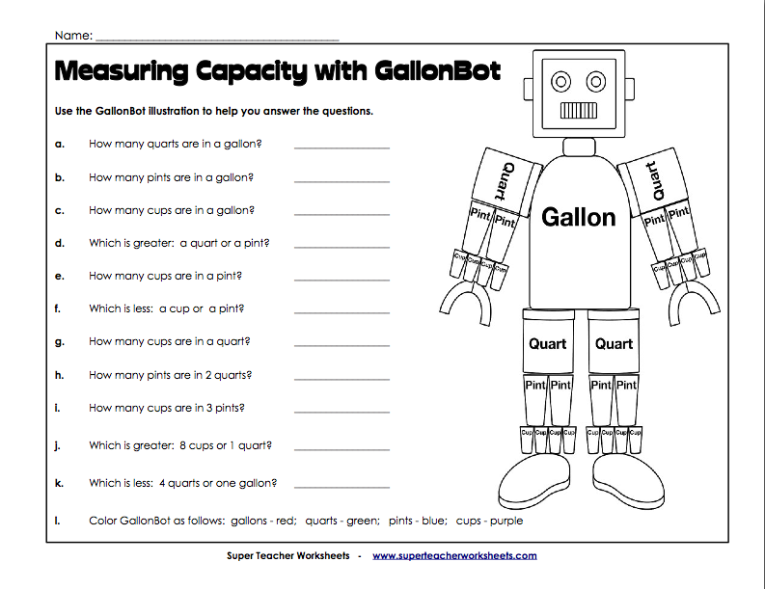
Source

MEASUREMENT: LINEAR

How Long or How Wide? A Measuring Guide by Brian Cleary (Heather Fisher)
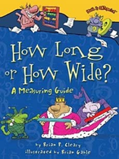
This is an engaging book to introduce measurement to your students! Focusing on length, this text doesn’t have a traditional story line but has rhyming text, colorful characters, and clever examples. With easy-to-understand comparison of metric and standard units of measurement, this is a useful resource for your measurement lessons.
Grades: 2-5
Source: Lucky Little Learners blog by Angie Olson. https://luckylittlelearners.com/childrens-books-teach-measurement

Jack Hartmann - Tall or Short [Youtube Video]: Kindergarten (Brivee Mueller)
- This is a good video to introduce the students to horizontal measurement. In this video tall and short are defined while also comparing items to familiarize the students with tall and short concepts. This video also doubles as a movement video as the kids can get up or move along. In my practicum I used the video as a transition time (between coming in from outside or washing hands) so that instructional time is not lost.
Grades: Kindergarten (or even Grade 1 review)
Source: Youtube - Kids Music Channel
https://www.youtube.com/watch?v=JjKhSyUVFBI

MEASUREMENT: MASS

Heavy or Light - Math Song | Nursery Rhymes and Kids Songs: Kindergarten (Brivee Mueller)
- This is a good catchy song that the students loved because they get to guess which items will be heavy or light and work on their mass measurement. It is very straightforward and easy to understand for the students. As a teacher, I really liked this song for transitions (or when the students were washing hands) because it was softer so it helped bring the students back down after loud lessons.
Grades: Kindergarten/ Grade 1
Source: https://www.youtube.com/watch?v=LMQIjLETmF4
Another good mass comparison video is: https://www.youtube.com/watch?v=qUOQrXmfwDM&t=91s

MEASUREMENT: NON-STANDARD

I’m the Biggest Thing in the Ocean by Kevin Sherry: Kindergarten (Brivee Mueller).
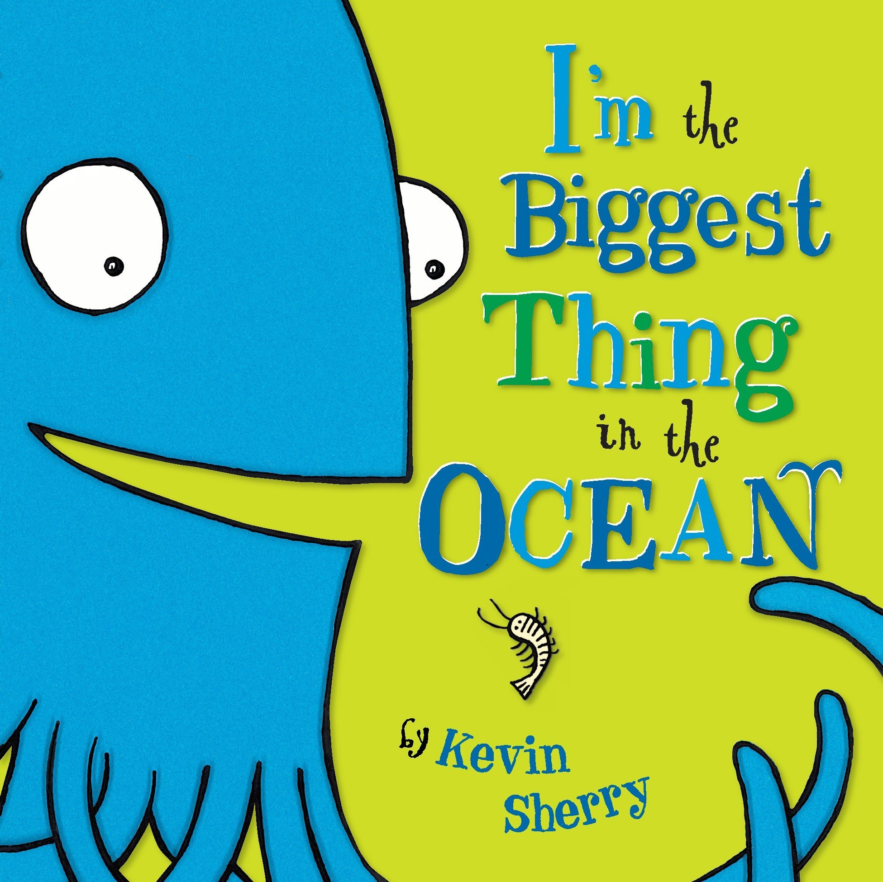
- I used this book as an introduction to measurement in general. This book is very good for comparing big and small as well as introducing the concepts of ‘biggest’ and ‘smallest’. I found this book to be a good visual which got the students curious about measurement. This book also uses real animals and compares their actual size so it can also have science content/ curriculum connections.
Grades: Kindergarten/ Grade 1

Non-Standardized measuring Video (Grades K-1) {Madison Hamborg}
I chunked this video into multiple lessons to fit with what we were talking about at that time. I used language from the video throughout the measurement unit with the students. (Salamanders came in a lot throughout the unit)
https://www.youtube.com/watch?v=2wUsdsae0ro&t=198s

Non- Standardized Insect Measurement (Grades K-1) {Madison Hamborg}

Lesson:Measurement (using non-standardized units) (K & 1)
Learning Intention: I can measure using non-standardized units
Introduction: I explained to student’s new language (shorter than, longer than) Students watched a fun video about measurement.
Instruction: Reflecting on the video, I showed them unifix cubes and asked questions related to the video they watched (are they all the same size/ length? Do we put them together or have them spread out? Do we measure on an angle?) students answered questions from knowledge of video. Show students bug measurement activity, explain that we go from one red dot to another red dot, and record the number of cubes used on the data sheet.
Independent Student Work: Students were at tables with a worksheet & insect measurement paper. Students measured insects from two dots to see how many cubes they all were.
Closing: Students compared with others at their tables to see if they got the same answers.

Source for Insect Measurement: https://www.teacherspayteachers.com/Product/FREEBIE-Insect-Measurement-Math-Center-for-K-1-Measuring-with-Nonstandard-Units-1807229?st=42629e1e85609efeb21d1ac9c90aaaf5

Multi- curricular enactment #1 (Math/ Science)
Plants: Grade 1 science curriculum
- We were growing plants in their classroom. Students could use their choice of non-standardized measurement to measure the plant stems
o Have the plants under document camera
o I would pre-cut strings the length of the plants.
This allows for students to be more accurate with their measurements
o Students will use cubes to measure the strings of the plants
Tape the string to their desks (students will be more successful with measurement if the string is not moving on their desk)
o Students can then predict which plant they measured based on the cubes they used— students can tape their string up on a poster board (teacher writes number of cubes they used)
o Compare as a class if they got similar answers or different answers and why

Multi- curricular enactment #2 (Math/ ELA)
- Students write their name on a name strip, and we then measured their names and then we put their names in order from shortest to longest.
o Teacher demonstrates appropriate way to write name (not too squishy & not too far apart)
o Students write their names on name strips—after all names are on teacher demonstrates how to cut it so it isn’t too long & so they aren’t cutting any part of their names
Students will not be penalized if they squish their name while writing or make it too big. This will be part of discussion about how we cannot base the length of our name on how we write it. – adaptation below
o **Addition if wanted** Students can predict who will have the longest name (the most cubes) and who will have the shortest name (the least number of cubes)
o Students then use cubes to see how long their names are (this is highly inaccurate for them due to how they write their name) Have discussion about how this is not accurate this is an estimate of their name’s length based on how we write them – if it was accurate, we would use a cube per letter of their name.
O Ask students to use new cubes and have a cube per letter of their name (teacher will demonstrate) Talk about how close they were with their writing compared to how many their name is.

Measuring Treasure Hunt with Caterpillars and Butterflies: Kindergarten - Grade 1 (Brivee Mueller)
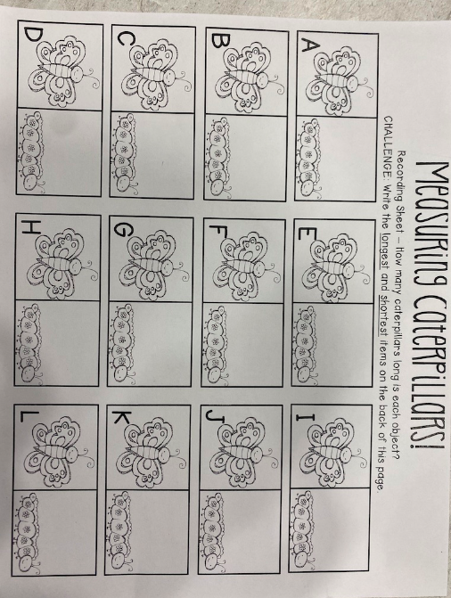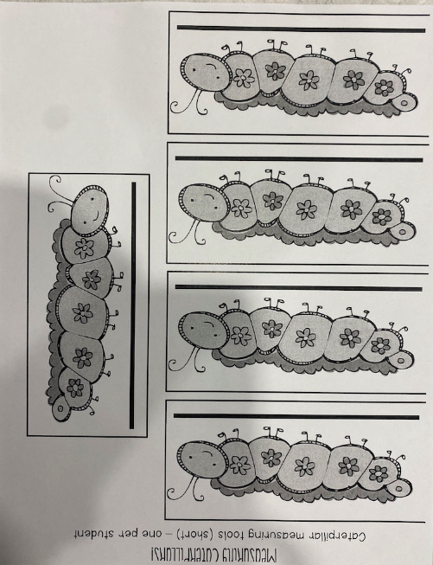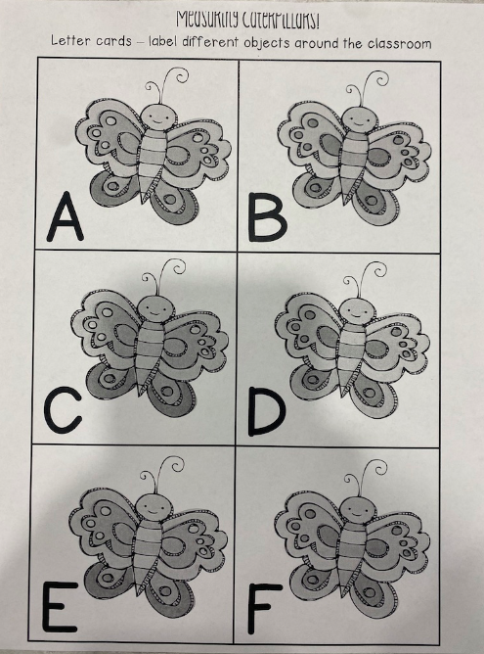
- This is a good activity for both vertical and horizontal non-standardized measurement. For this activity, place the alphabet labels around the classroom on various objects and get the students to use their ‘caterpillar measuring card’ to see how many caterpillars tall/long the objects are and record their answers on their recording sheet. This is a good activity to see if students know how to measure and what both horizontal/ vertical means.
Grades: Kindergarten/ Grade 1
Source: I got this from my coaching teacher, but I have a hardcopy of the template if anyone wants it.

Non-Standardized Measurement Enactment (Brivee)
Core Lesson Outline:
Lesson: | Measurement: linear/ non standardized. (Kindergarten)
Learning Intention: | I can use my ‘caterpillar’ measuring tool to measure various familiar classroom objects horizontally.
Introduction: | Give the students a brief review lesson on long and short – horizontal and tall and short – vertical measurement. As a movement break and a review activity, play “Tall and Short Jack Hartmann Measurement Song '' so the students can have a refresher on these types of measurement.
Instruction: | Gather the students at the carpet area and go over the measuring lesson and the rules/ expectations. Brief overview: students will be given a caterpillar measuring tool and they will find the different butterfly markers around the classroom and measure the objects attached to the marker. During the instruction, the teacher will give a demonstration of how to measure horizontal [horizontal measurement will be the focus of this lesson]. Before dismissing the students, the teacher will ask students to raise their hands to give examples of the expectations for the activity to check for understanding.
Independent Student Work: | During the activity portion of the lesson, the students go on a ‘scavenger hunt’ around the classroom for the butterfly markers and measure using their caterpillar measuring tool and filling out their answering sheet for each object. While the students are doing their measuring work, the teacher will circulate the classroom asking the students to demonstrate their measuring skills to check for understanding on how to measure.
Closing: | Students will gather back at the carpet and together as a class we will discuss our findings. Students will help the teacher fill out a chart paper on the ‘longest’ and ‘shortest’ items they measured. Class will have a discussion which will lead back to the learning intention: how did the activity go, what did they like, what was hard.

Multi-Curricular Enactment #1
Curriculum Areas: Math/ Outdoor Education/ Physical Education (Kindergarten)
For this lesson the students will explore what they have learned and created in previous lessons to a fun movement activity outside:
- Teacher will have set up a game outside where the students will have to use their measuring skills to play a restructured game of ‘what time is it Mr. Wolf’
- Rules for the game: [the same as regular ‘Mr. Wolf’ but focused more on measurement]
o One student/ or the teacher will stand far ahead of the others and call out ‘times’ which will be steps that the students have to take.
o Students will practice their measuring skills so they will put their feet back-to-back [and not take actual big ‘steps’ because that’s not how we measure].
o Students will take turns being the wolf and will be asked to choose numbers between 1-10 to keep the counting work manageable for all students.
- Teacher will remind the students that in order to measure, we have to use our measuring tool ‘back-to-back’ with no spaces in between them. For this game, our measuring tool will be our feet, so students will have to put their feet one in front of the other in order to measure correctly.
- During the activity the teacher will watch the students and look for the student's ability to use their measurement knowledge. In the future, this can be used as formative assessment to determine understanding and need for future lessons.
- After the activity – ask the students why some students might have moved farther faster than other students [answer – our feet aren’t all the same size/ so our measuring tools aren’t all the same].
- Extension: Ask the students in advance to bring a pair of shoes from home that belong to one of their older siblings, a parent and get the students to try with and without these shoes. As a class we will discuss and compare the results: which do we travel faster in? Which one is a bigger measuring tool? The teacher will guide the discussion and record out findings as a class of the two different non-standardized measurements.

Multi-Curricular Enactment #2
Curriculum Areas: Math Non-Standard Measurement/ ADST (Kindergarten)
Learning Intention: I can create and use my own measuring tool.
Introduction: Teacher will show the students the read aloud for the book “How Big is a Foot” and have a discussion on why it is important that we all use the same measuring tool – so we all get the same answers when we measure.
Instruction: Explain to the students that today, we are going to make our own measurement tools. Even though everyone is making their own, they will all be the same size [use material like chopsticks so that students can decorate them, but they will all be the same size in the end]. Teacher will explain that students will each get a chopstick, and then they can decorate with colors [markers], pipe cleaners, gems, stickers, and more.
Criteria:
- The goal is to make measuring tools that are the same length – meaning we can’t add to the ends, only decorate and design them.
- We are all making our own, so we can share ideas, but we make one each.
- We use our materials and tools responsibly.
- You only get one chopstick to decorate – so plan and create carefully.
Independent Student Work: Students will use their own problem solving, creative thinking and ideas to create/ design their own measurement tool that is unique to them. As the teacher circulates, she will ask them about their ‘design plan’
When students finish creating their measuring tool – get the students to come get supplies [construction paper, tape] and design then create/ decorate/ ‘assemble’ a bed [maybe for one of the toys/ stuffed animals in the classroom] that the students will now measure using their new measuring tool. As more students finish, pair them off and get them to compare their structures and measuring tools.
Closing: At the end, the students will do a pair share with a partner where they can show off their new measuring tool and also measure an object in the class together to test out if our tools are the same size. Students will get to test their measuring tools and share their results at the end of class.

MEASUREMENT: TEMPERATURE

Food coloring temperature experiment (Grade 1,2,3)(Alex Horner):
Students get to see how temperature affects density. In this, students mix(or watch the teacher mix) food colored water. One color of water is cold (blue) and one color of water is hot. Students will observe that the two colors resist mixing for some time, eventually combining when their temperatures equalize. This can be a good visual for students as they can better understand an important element of temperature. This lesson could introduce or supplement a lesson on weather as this phenomenon is a driving force for the earth's climate.
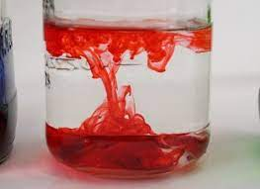

MEASUREMENT: TIME

Build a Sundial! (2-12)(Alex Horner)

Time is generally based on the sun so why not create a sundial to show students how the sun can tell the actual time like a clock. This will take some time to create, however, it will be cool once it is finished. If this project goes over most of the year, students can also create a sun callander. In this, the sun will point to the correct day of the year with its shadow.

Here are some resources to further explain how to do this:

Clock: https://www.youtube.com/watch?v=-_lp_usCb5Y

Calendar: https://www.youtube.com/watch?v=qyTyZmNcW6g

Paper Plate Analogue Clock - 3-4 (Allison Geyer)
Materials:
- Paper plate, arrow hand templates (pre cut)
- Brass plate fastener, marker or number stickers (1-12)
Begin by having students write down the numbers on the clock or using the stickers. For advanced learners, having them draw the minute lines as well. Students will then safely use a single hole puncher to make a whole at the center of their plate. Then, using the arrow hand templates, make sure to put the bigger hand is on top while the little hand is under neath, attaching them to the plate via the fastener. Optional: Add decorations to spruce up their own personal clocks. Use this during instructional time to have students represent the times on their own personal clocks.
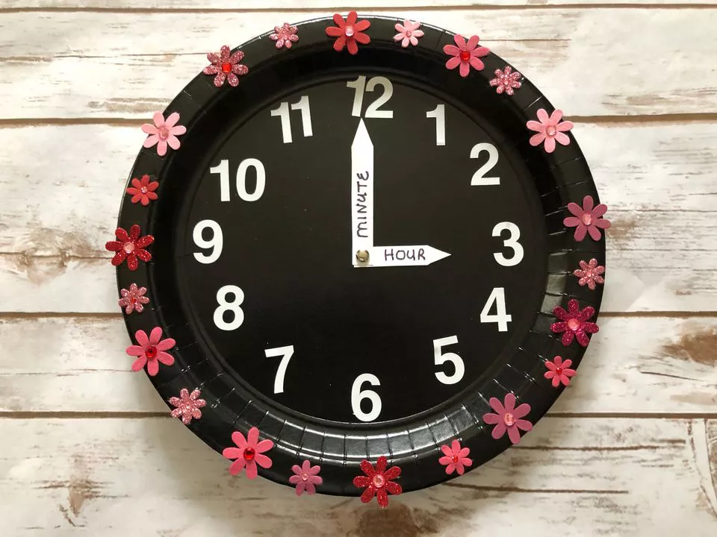

MEASUREMENT: VOLUME

More of Less (An Introduction to Volume)-- Grade K/1 (Vicki Chen)
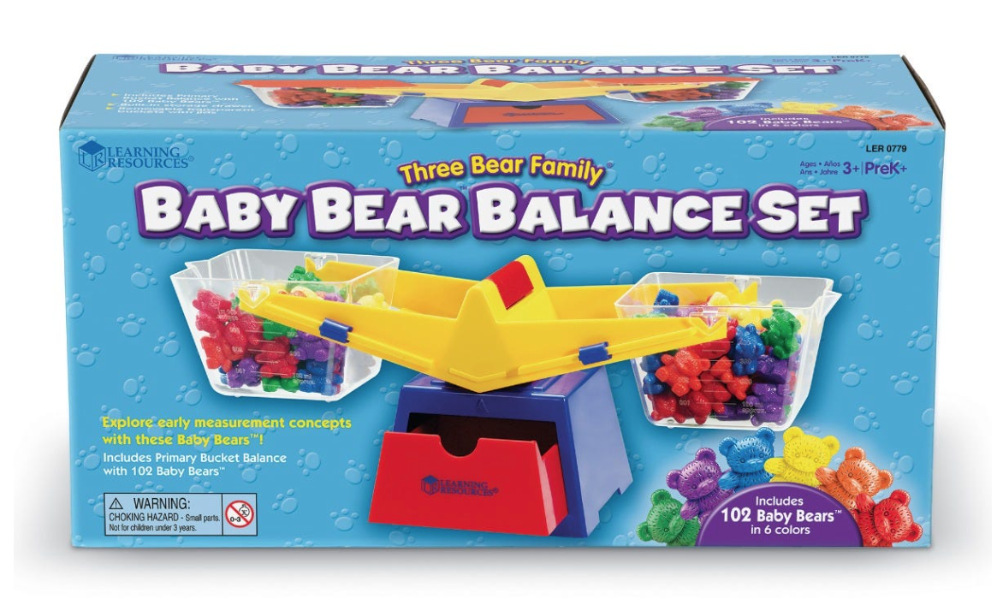
Tool: Using the Baby Bear Balancing Set, students experiment, observe, and play with a balancing lever. By adding or subtracting bears, the students can see how putting more into one side will lead to the lever tilting. Students can experiment by creating balance with an equal number of bears on each side.
Where you can get it: https://www.learningresources.com/three-bear-familyr-primary-bucket-balance

MEASUREMENT: VOLUME

Understanding the Origins of Volume (5-7) (Alex Horner):

Volume was created by Greek thinker Archimedes as a way to determine if a nobel was being overcharged for gold. Students too can do the same experiment as Archimedes and determine the total volume of any object they like. All that is needed is a standardised container (5L tupperware for instance (with marked increments)), a measuring cup, and objects to measure.

In this experiment, student can measure the volume of objects and see their exact volume. If the object is made of of a pure substance like lead or GOLD, students can determine the purity of the object. EX: If a crown displaced 10kg worth of gold but only weights 5kg, we know that we are not getting what we payed for…

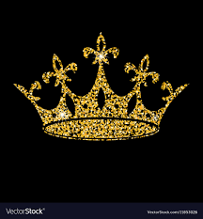

MULTIPLICATION
Math Arrays- Gr. 2-7 (Nicole M)
- Students can use white boards to draw and represent multiplication, math manipulatives, any object that they can create groups out of to create an array that will demonstrate two numbers being multiplied together and creating a sum.
- https://www.youtube.com/watch?v=00m3YhLT6fA (This is for gr. 2 but can be a way to show students in simple terms)
Multiplication Chart Fill in the Blank- Gr. 3-7 (and on) (Nicole M)
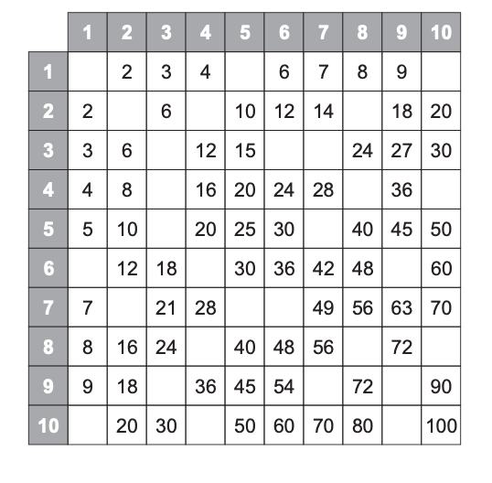
- Helps students become confident in learning their multiplication facts. Can have multiple options of completing or filling in the blanks so that students can practice and familiarize themselves with it. (Google is a great place to find multi-versions of this, but you can ask and I can share the ones I have as well)

Multiplication Bump: Matching Equations to Arrays: Grade 3 (Brivee Mueller)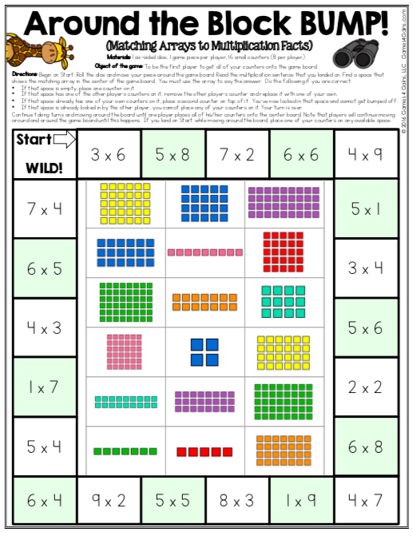
- This is a fun math game that helps students become comfortable with using arrays to connect to multiplication. This game can also help students become familiar with their multiplication facts from 1-9. In the game, the students have to roll the dice, match the multiplication equation to the array, give the answer and then they get to place their tile on the equation. When their partner gets on the same spot, the students can ‘bump’ one another unless there are two of their opponent’s tiles already on it to ‘lock in’ that place. A good tip - put this game in a dry erase pocket sleeve so that the kids can play it over and over again without having to continuously reprint.
Grades: 3-4
Source: This is a freebee from Teachers Pay Teachers (and if ever needed, I have the template as well).

Multiplication flashcard game Grade 4-7 (Priya Sandhu)
https://www.multiplication.com/games/play/quick-flash-ii This is a link to an online multiplication flashcards game. It has different levels and multiple parts to the game. A very fun way for students to practice multiplication.

Multiplication War – Grades 3-7 (Keely Murray)
Students in pairs use a deck of cards (either a specially made deck or just a deck of playing cards with the face cards removed) and play the card game War with a twist. In the game War, each player gets half the deck of cards. They then flip over the top card at the same time. In the classic game, the player who flips the higher card takes both cards and adds them to the bottom of the deck. In this version, though, both players need to multiply the cards flipped over (ex. One player flips a 6 and the other flips a 2. They need to multiply these cards to get 12). Whoever completes the multiplication fastest gets both cards. The goal of the game is to make your opponent run out of cards. This game can be easily adapted (ex. Adding in face cards with “11” or “12” written on them (or just acknowledging that Jack means 11 or Queen means 12), or by taking out numbers that students haven’t learned the multiples of yet), and can be done so that students with a similar level of multiplication knowledge are paired up to make it more fair, or by not doing it timed and instead having students wait until both have a number in their head and then saying it at the same time. Game can also be easily adapted for addition.
Source: I played this game when I was in elementary school.

Skip Counting Game - Grade 3-4 (Allison Geyer)
A fun, quick little game to play between lessons that assists in solidifying students' understanding of skip counting and multiplication. Students are to arrange themselves into a circle with one being the leader. The leader chooses a number to skip by (IE. 3) the students will go around going up by 3 each time until they reach the multiple of ten.
- For example, the leader starts at 3, the next student is 6, the next is 9 and so on. Once a student is at 30 they must say their number and sit down. Repeat the process until there is one student standing.
- For an additional challenge, or have it go by faster, have students choose if they wish to go up by 3 or go up by 3 twice.

NUMBER SENSE AND CONCEPTS
“Sir Cumference and the Roundabout Battle” book by Cindy Neuschwander (Grades 2-4) Samantha Morey
This book is really nice to read to students when teaching them approximating sums or rounding to the nearest 10 or 100. The storyline follows a young boy who needs to count up materials around a kingdom in order to prepare for an upcoming battle. It starts off with him doing addition, but then when he has less time to do perfect math he begins to approximate and shares his techniques for doing so. If I were to use this in a classroom I would probably read it aloud once the students are familiar with adding to 100, and then go through it again to do the math problems that the main character is presented with so that they could feel immersed in the story, and then go into a lesson about rounding or approximating.
Source: Bonnie Fuller
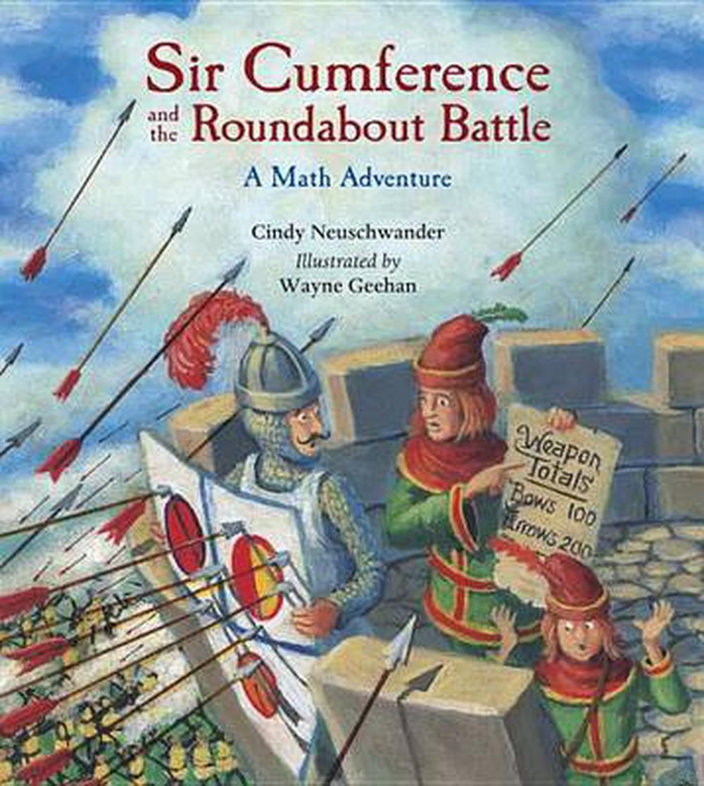

ORDER OF OPERATIONS
Order of Operations Card Game (Grades 5-7) (Samantha Morey)
This game would be played in pairs within the classroom and is great for filling time or practicing their order of operations skills. All the students need for this is a desk or table and a deck of regular playing cards. To start, one of the students will draw 6 cards for each partner (12 in total) and place them face up in front of each student. The aim of the game is to use order of operations to get a sum of as close to 24 as possible! It is really harder than it sounds but the kids in my class were amazing at it and beat me every time. In this game, Aces were worth 0, Jacks were 10, Queens were 11, and Kings were 12.
The game can end a couple of different ways. Either the first one to get to 24 wins OR if a sum of 24 is not possible, the one to get closest to 24 would win!
Source: My Coaching Teacher from EDUC 490 and his students

PATTERNS
“Bounce” Game (Samantha Morey)
This game could be played really with any grade to practice many different subjects of Math, but I found that it all ties really nicely into patterns. The idea of the game is that everyone in the class stands up in a circle facing each other. The teacher decides what pattern they will be playing by (I observed this in a K class so they were counting backwards from 10, but it could also be counting up by 2’s, 10’s, multiples of 5’s, Prime Numbers, whatever you need). The teacher will start with the first number, for example “10”, then the next student in the circle will count down and say “9”, the next student will say “8” and on and on until a student says “0”. When a student says the last number in the sequence everyone else says “bounce” and that student has to sit down, and the pattern restarts. I like this game because it is super flexible for really any grade and any type of pattern and then eventually at the end of it there will be one more student standing and they can be the winner of the round!
Source: Kindergarten teacher at my last practicum placement

Finish the Pattern (Grades 2-3) {Madison Hamborg}
We did this as a class, independently and then with partners. I gave them an example on the board where we discussed as a group as to what was going to be in the blanks. I used the (finger on your nose if you think….) As a group we discussed why it could/ could not be certain shapes. - I then gave them all pattern blocks to do the patterns at their desks. I did an individual finish of the pattern so I could see as the teacher where everyone was with this. For the partner work, I asked the students to make a pattern and ask their partner to finish it and vice versa. Students played around with the tangram and making of patterns. We then did a share if they wanted to share their patterns with the other students in the class.

PROBABILITY
“A Very Improbable Story” by Edward Einhorn, Grades 5-7 (Sidney Rud)
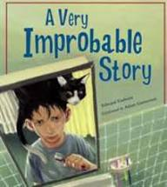
This story does not only have lots of good math content but is very entertaining as well. The storyline follows a cat named “Odds” who likes to play games and Ethan. Odds makes Ethan solve different probability questions throughout the book. I think this book would be good for base material because it has a lot of different probability questions/activities built in. You could use this book to go with a string of probability lessons by acting out and or discussing each different activity on different days.

Source: Bonnie Fuller

Here is a link to a read aloud version on youtube: https://www.youtube.com/watch?v=5_h839Sf-2g

RATIO AND PROPORTION

Splitting the bill - Grades 6-7 - Alex Moore

I also work on splitting a bill with students when we are discussing ratio and proportion. I tell a story of my mum taking my sister and I out for lunch with her friend who had one son. The bill came to $50 and then we discuss how much my mum and her friend should pay.

The Giant’s Loo Roll by Nicholas Allan - Grades 3-6 - Alex Moore

I haven’t used this but it was suggested to me by a colleague.
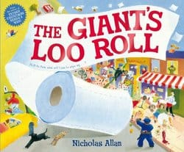
﻿Synopsis by the author/publisher
This rip-roaring, read-aloud delight follows a giant's toilet roll as it goes on a crazy journey through town, leaving havoc in its wake. What will the townsfolk do with all the enormous sheets of paper? They could build a paper plane, or make 100s of pairs of pants. . . But will there be any paper left for the giant in his time of need?​

SUBTRACTION
Race to 0 -- Grade 2 (Vicki Chen)
Pair up students. Each student writes “100” on the top part of a paper, it leave out lots room for subtractions. With a deck of cards between the pair, begin by each student flipping a card over. Take the value of the card away from “100.” Each student flips another card each. Take those values away from the new total and continue until one of the students reaches exactly “0.” If the cards run out, the student with the lowest value wins. To make it more advanced make the Jack equal to 11, the Queen equal to 12, and the King equal to 13.

Math Worksheets Resource k-7 (Priya Sandhu)
https://www.math-salamanders.com/4th-grade-math-problems.html this website has hundreds of free worksheets for multiple math concepts and for every elementary grade. I found some great math challenge questions on this site that I used for number talks and word problems.

